Categorization and Analysis of Power System Transients

Math H. J. Bollen*, Fellow, IEEE*, Emmanouil Styvaktakis, and Irene Yu-Hua Gu*, Senior Member, IEEE*

***Abstract—*Power system transients are power-quality distur- bances that can be harmful to electronic equipment. This paper contributes and provides some solutions to the following issues:**

1. **to introduce a new way to identify different categories of power system transients based on their underlying causes; 2) to propose a model and analysis tool for oscillatory transients, where emphasis is on finding phenomena and characteristics associated with the underlying causes of transients. A model-based approach, ESPRIT, is applied to a number of simulated voltage waveforms to extract the parameters of oscillatory transients, and the results may be used for identifying and understanding the causes of transients by correlating the major components in transients with the phenomena that may appear in different types of transients and some *a priori* knowledge of power system settings.**

***Index Terms—*Damped sinusoidal model, estimation of signal parameters via rotational invariance techniques (ESPRIT), power quality, power system transients, power transmission and distribution.**

* 1. INTRODUCTION

**T**

HE TERM “transient” originates from electric circuit theory where it denotes the voltage and current com- ponent that occurs during the transition from one (typically sinusoidal) steady-state to another steady-state. Electric cir- cuits are described by means of differential equations, whose solutions are the sum of a homogenous solution and a par- ticular solution. The particular solution corresponds with the steady-state; the homogeneous solution corresponds with the transient. In electric circuit theory a transient is always associ-

ated with a change in steady state due to a switching action.

In power systems the term transient is used in a slightly dif- ferent way: it denotes those phenomena in voltage and current with a short duration. There is no clear limit, but *phenomena with a duration of less than one cycle (of the power-system fre- quency, 50 or 60 Hz) are generally referred to as transients*. The interest in power system transients has traditionally been related to the correct operation of circuit breakers [1], [2] and to overvoltages due to switching of high-voltage lines [3]. But more recently transients are viewed as a potential power-quality problem [4]. This places new requirements on characterization

Manuscript received November 26, 2003; revised June 30, 2004. Paper no. TPWRD-00596-2003.

M. H. J. Bollen is with STRI AB, Ludvika 77180, Sweden and also with EMC-on-Site, Luleå University of Technology, Skellefteå 93187, Sweden (e-mail: m.bollen@ieee.org).

E. Styvaktakis and I. Y.-H. Gu are with the Department of Signals and Sig- nals, Chalmers University of Technology, Gothenburg 41296, Sweden (e-mail: i.gu@ieee.org).

Digital Object Identifier 10.1109/TPWRD.2004.843386

and analysis of transient waveforms. Relations have to be es- tablished between waveform characteristics and equipment per- formance; methods have to be developed to extract information on the cause of transient waveforms; and methods are needed to quantify site and system performance.

Power system transients are due to a range of causes, the main ones being lightning strokes to the wires in the power system or to ground and component switching either of network compo- nents or of end-user equipment. Power system transients pose a number of interesting and challenging problems, including the accurate modeling of the power system at higher frequencies and the characterization of measured transient phenomena. This paper will concentrate on the latter problem.

In terms of classification, power system phenomena can be divided into three classes [5].

* Events that can be classified by their fundamental fre- quency magnitude. These events contain parts where the voltage magnitude goes through significant changes for long periods. These changes are well apart in time so that magnitude estimators have no difficulties in resolving them. This class consists of the majority of fault-induced events, transformer saturation, induction motor starting, etc. Examples are voltage dips (with duration typically be- tween 50 ms and several seconds) and interruptions (with duration from several seconds up to many hours) [6].
* Events that present significant changes in the fundamental frequency magnitude but of short duration. The extraction of the voltage magnitude becomes problematic for these events. This class contains fuse-cleared faults and self- extinguishing faults.
* Events of very short duration (*transients*) for which the fundamental frequency magnitude does not offer impor- tant information. For this class, the higher frequency com- ponents of the signal must be considered for a thorough characterization and classification.

The aim of this paper is first to describe some causes of transients (mentioned in the 3rd class above) through giving examples, subsequently to show how signal-processing tech- niques can be applied to extract useful information from the transients due to different causes. After considering the cate- gorization of transients both from their waveform shapes and underlying causes, damped sinusoidal models and estimation of signal parameters via rotational invariance techniques (ES- PRIT) method are then introduced for analyzing power-system transients having an oscillatory waveform shape in order to associate the phenomena and characteristics of transients and their underlying causes.

0885-8977/$20.00 © 2005 IEEE

Most previous work on ESPRIT was applied to speech and other types of signals [7]. The ESPRIT method was used in

[8] to estimate the parameters of a damped 1.2 kHz oscillation (generated by switching a capacitor) superimposed on the 60-Hz sinewave. It was shown that the method is able to accurately es- timate the frequency of the oscillation even after adding a high level of white noise. Our aim here is to employ ESPRIT as an analysis tool to the power system transient data with unknown underlying causes. From the obtained signal components and the general knowledge on power systems, we then try to asso- ciate certain characteristics (or phenomena) and the underlying causes of the transients.

* 1. CATEGORIZATION OF POWER SYSTEM TRANSIENTS

A detailed description of power system transients is far be- yond the scope of this paper. The reader is referred to the few books that are available on this subject [1], [2]. Here we suf- fice with a short and admittedly incomplete overview and some examples.

Power system transients, based on waveform shapes, can be classified into “*oscillatory transients*” and “*impulsive tran- sients*” [9]. According to the possible causes of transients studied in this paper, they can be further classified as events, briefly summarized in Table I.

1. *Impulsive Transients*

An impulsive transient is a sudden change in the steady state condition of voltage, current or both, that is unidirectional in po- larity (primarily either positive or negative) [9]. Impulsive tran- sients are normally characterized by their rise and decay times. They are damped quickly by the resistive circuit elements and do not propagate far from their source.

The most common *cause of impulsive transients* is lightning. When a lightning stroke hits a transmission line (direct stroke) an impulsive overvoltage is induced [10]. Lightning overvolt- ages can also be induced by nearby strokes to the ground or be- tween clouds. These overvoltages are of lower magnitude than those produced by direct strokes. Fig. 1 shows an impulsive transient measured in a 132 kV network. As can be seen from the figure, modeling an impulsive transient as a sudden rise fol- lowed by an exponential decay does not hold in this case. This turns out to be true for many measured transients. In the above case, the voltage waveform shows a sudden rise followed by a sudden drop and an oscillation with a relatively small amplitude.

1. *Oscillatory Transients*

Oscillatory transients show a damped oscillation with a frequency ranging from a few hundred Hertz up to several megahertz. Mathematically, oscillatory transients are the homo- geneous solution to linear differential equations. As the electric power system can, as a good approximation, be described by a set of linear differential equations, oscillatory transients are the “natural transients” in electric power systems. Therefore oscillatory transients dominate over impulsive transients.

*A typical example of an oscillatory transient is caused by the energizing of a capacitor bank*. The oscillation frequency

TABLE I

CATEGORIZATION OF TRANSIENTS BASED ON WAVEFORM SHAPES AND THEIR UNDERLYING CAUSES (OR EVENTS)

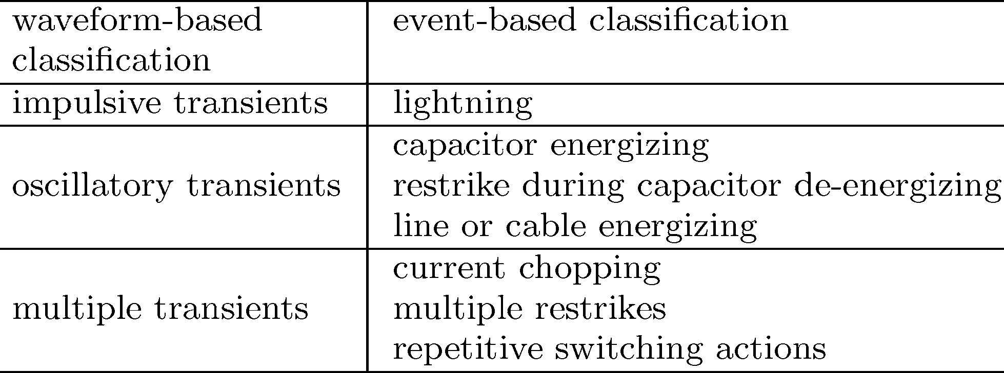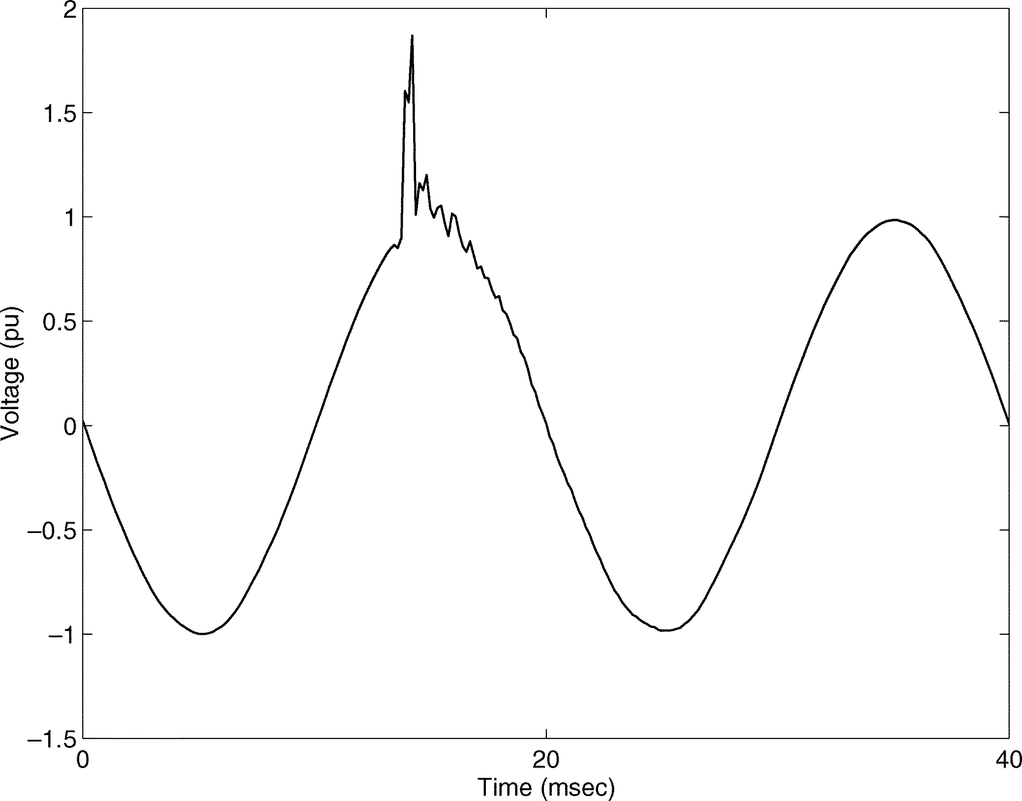

Fig. 1. Voltage waveform of an impulsive transient (measurement in a 132-kV network).

is mainly determined by the capacitance of the capacitor bank and the short-circuit inductance of the circuit feeding the capac- itor bank.

* 1. *Capacitor Energizing With Magnification:* The system of Fig. 2 is simulated in EMTP for energizing the 12.5 kV capac- itor bank when a fixed capacitor bank is connected to the 480 V bus. The line is modeled using lumped elements, therefore the influence of travelling waves is neglected. The short circuit level of the source is 250 MVA. The capacitor being switched is

2.5 MVAr and the capacitor bank at 480 V is 170 kVAr delta con- nected. The resulting transients at the high and low voltage buses are shown in Fig. 3. The peak value at low voltage is 2.5 pu, sig- nificantly higher than the peak at high voltage.

Fig. 4 shows the spectrum of the transients. The transient at the 12.5 kV bus shows a peak close to 450 Hz. The spectrum of the transient at the 480 V bus shows two peaks: one at the same frequency as the transient at 12.5 kV and another around 700 Hz. Their amplitudes are almost equal. As described in [11], the presence of a second capacitor in the vicinity of the capacitor that is being switched produces a transient which is the combi- nation of two frequency components. Formulas for the calcula- tion of these frequencies are given in [11]. Furthermore, more resonance frequencies appear if more capacitors are close.

* 1. *Capacitor Energizing Without Magnification:* For a dif- ferent capacitor size at the low voltage bus, the peak voltage is reduced significantly. For example, if the 480-V capacitor bank

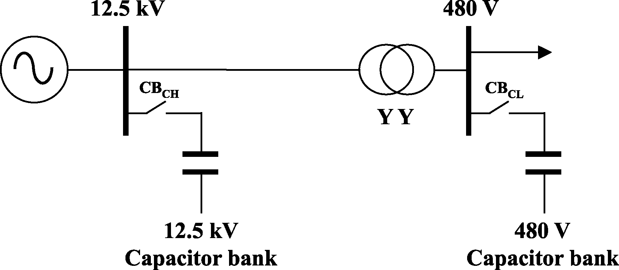

Fig. 2. Distribution system for the simulation of voltage amplification due to capacitor energizing.

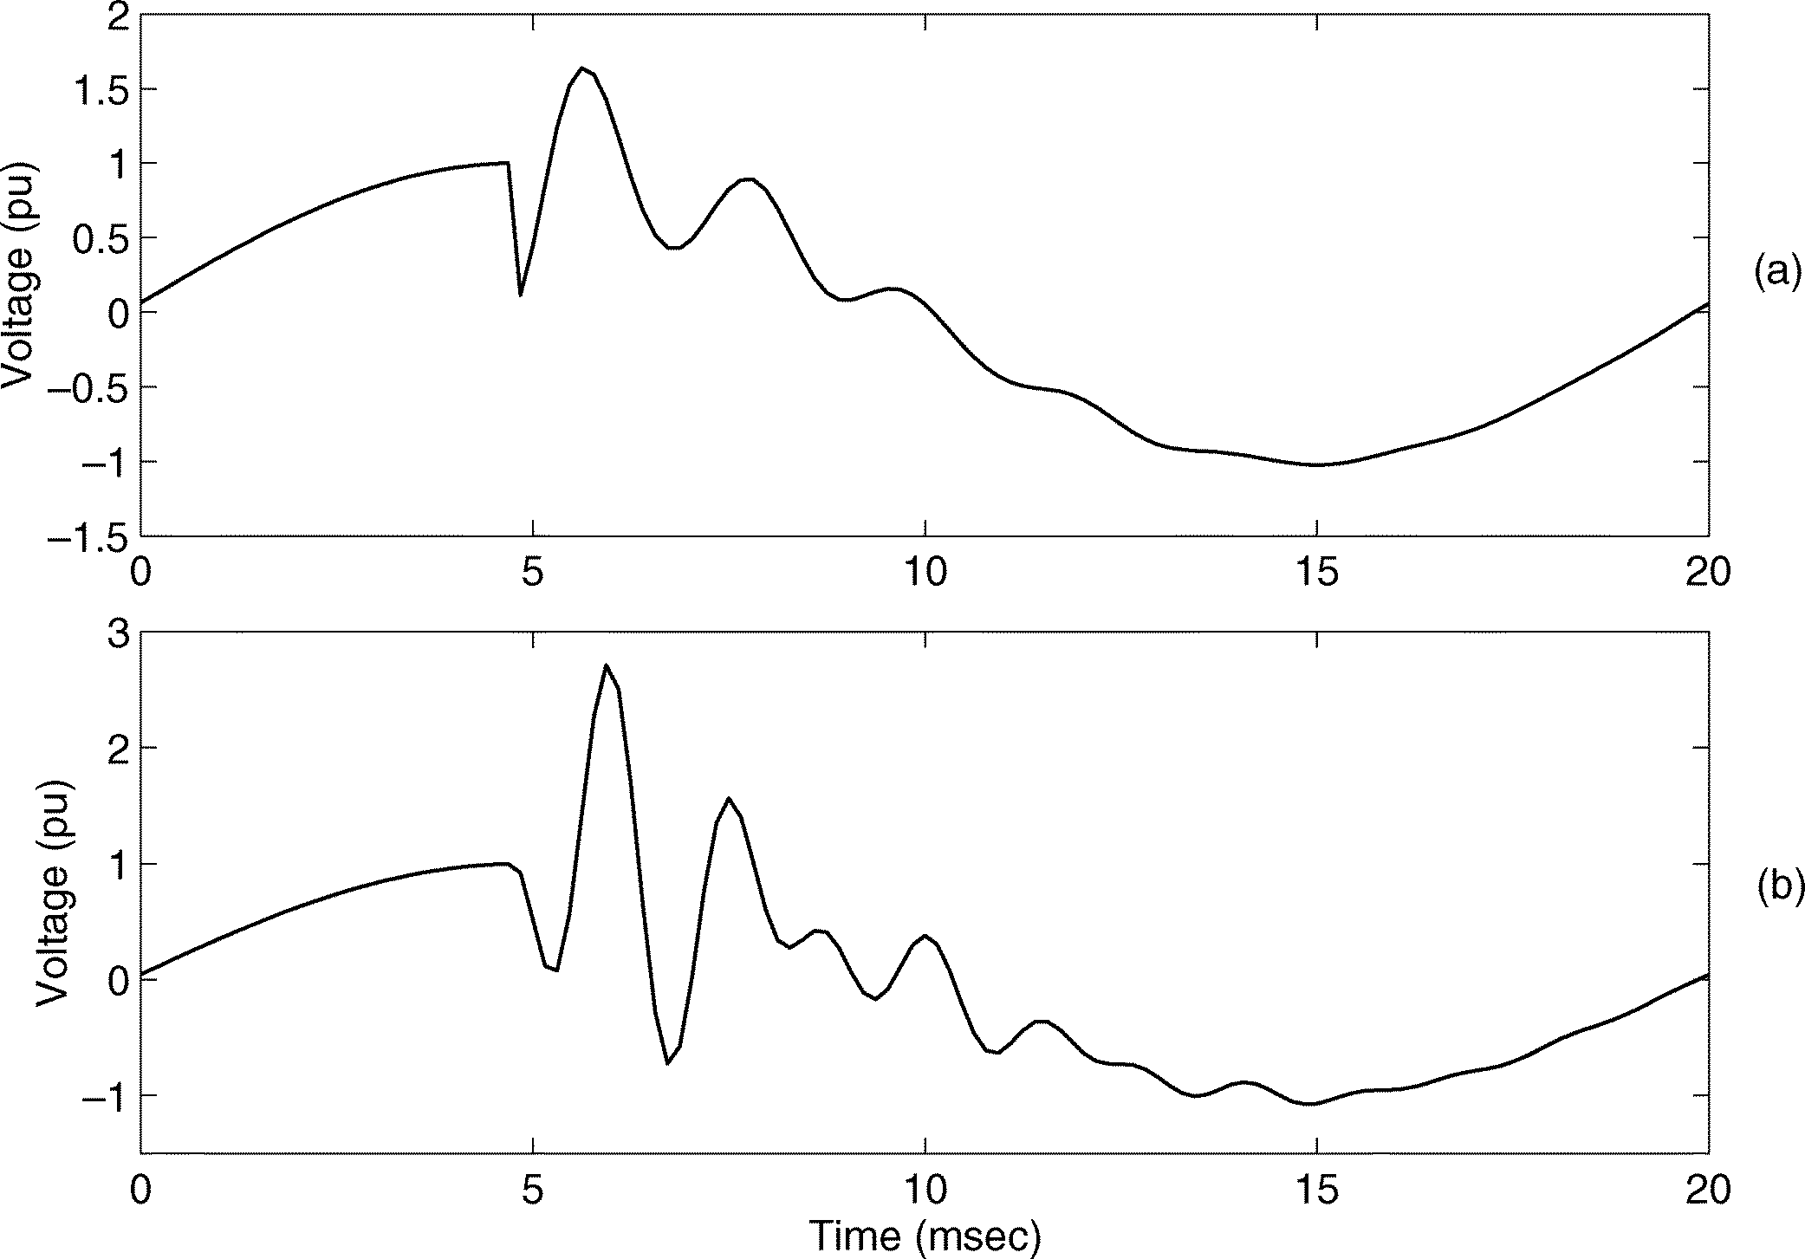

Fig. 3. Voltage waveforms during capacitor energizing. From top to bottom:

(a) at 12.5 kV; (b) at 480 V (ATP-EMTP simulation).

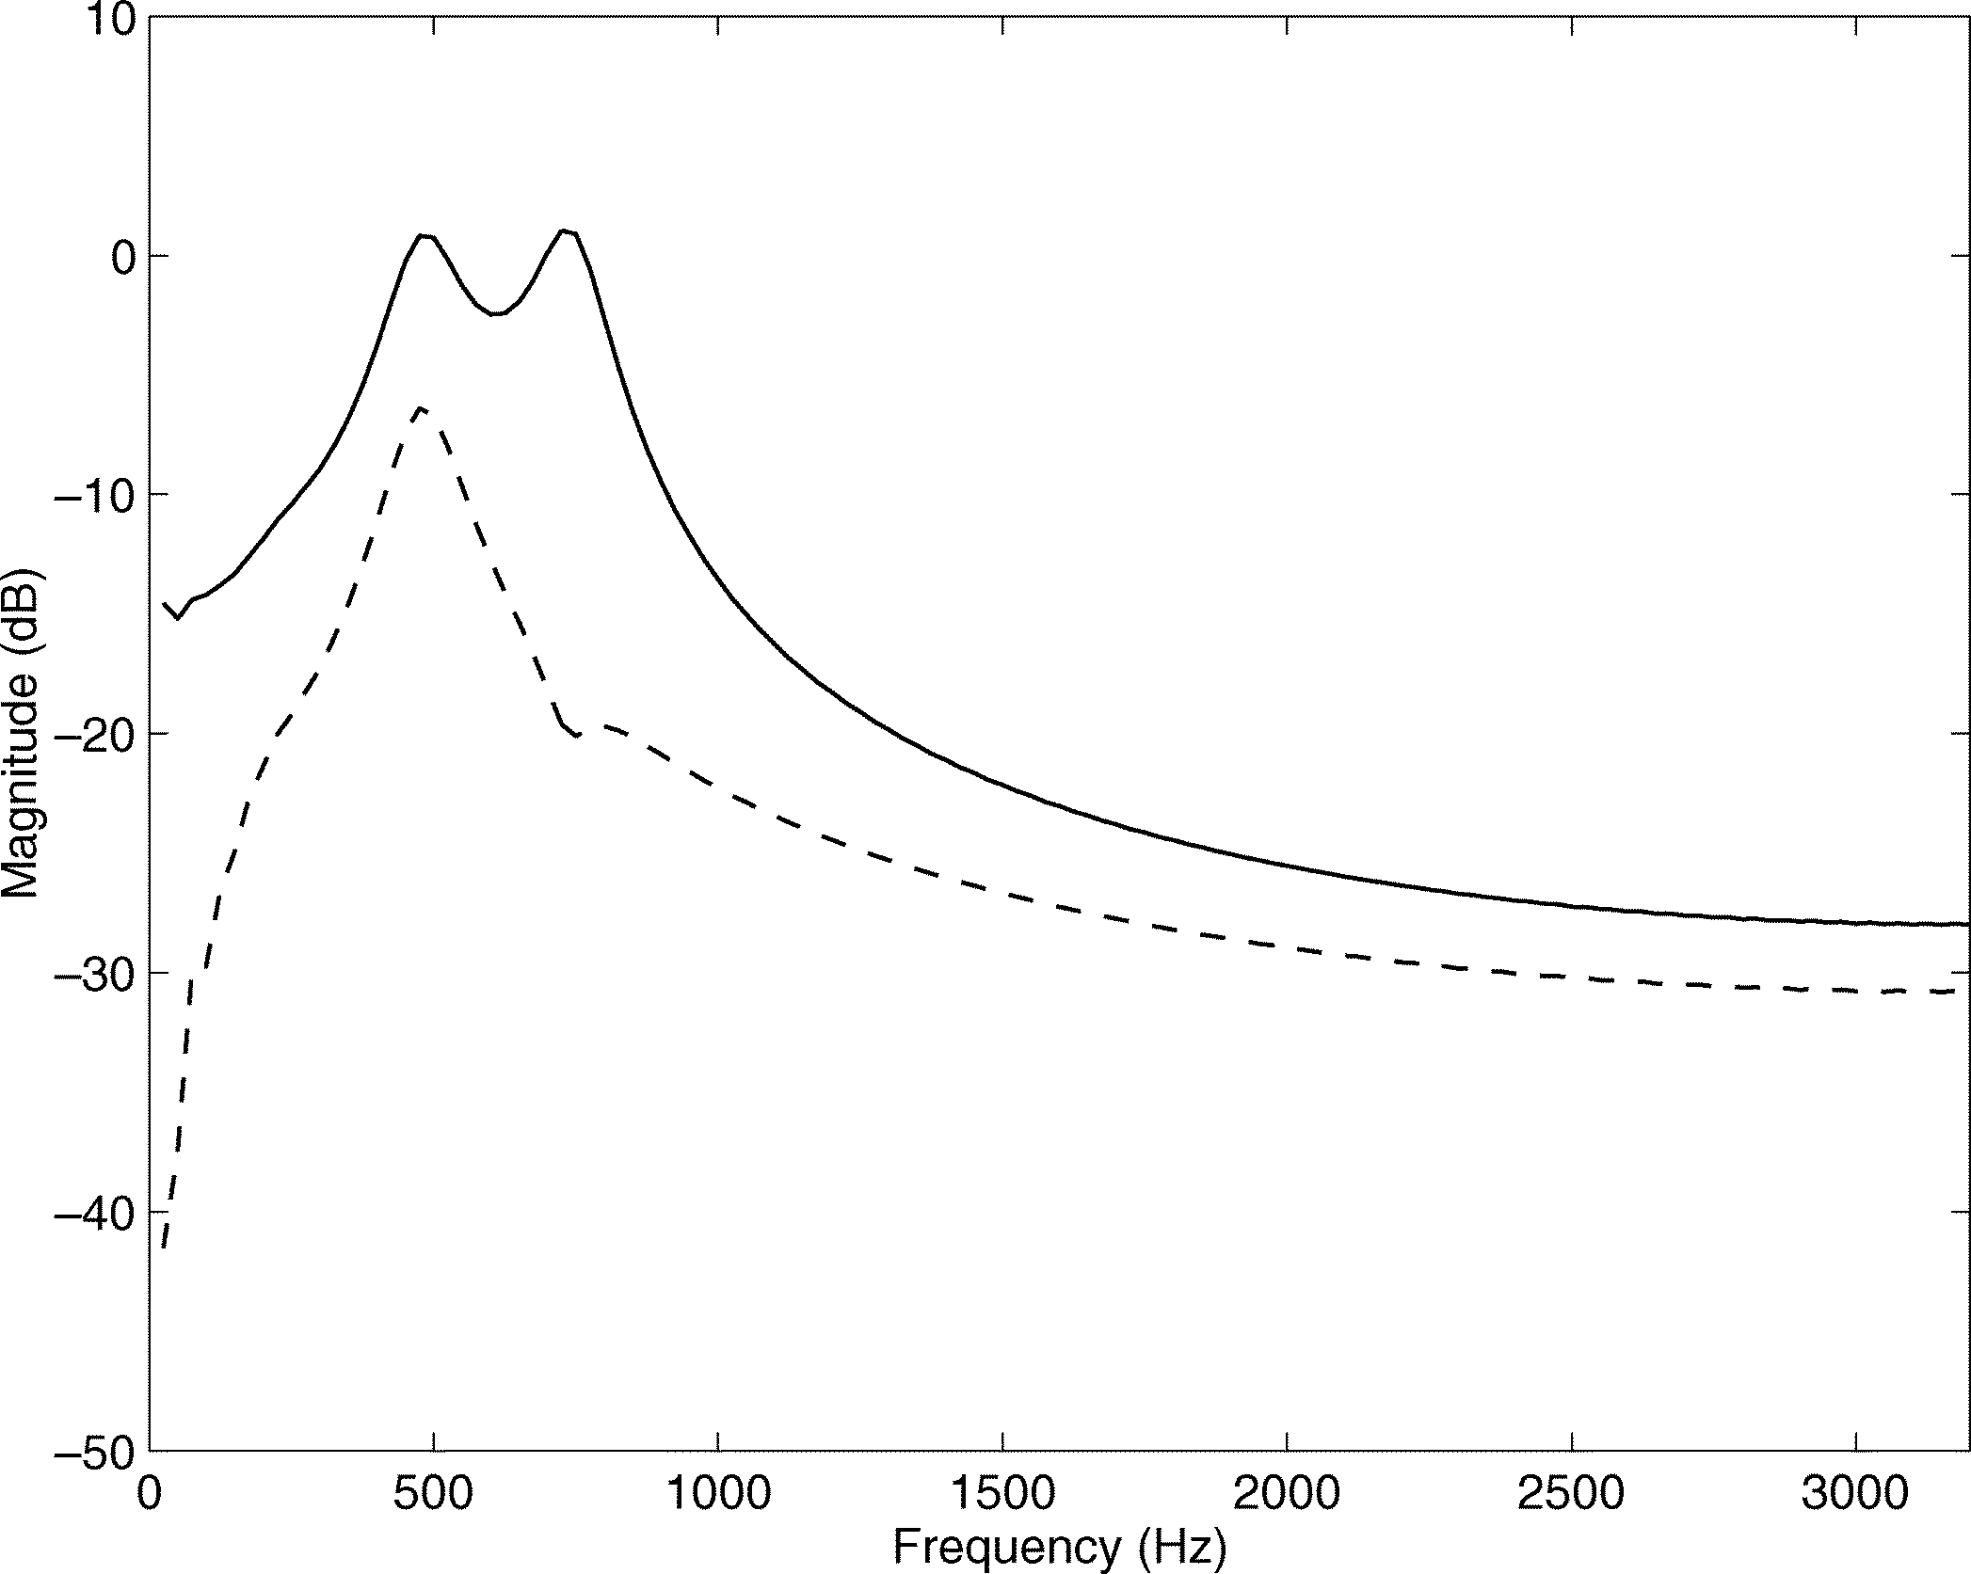

Fig. 4. Spectrum of voltage transients shown in Fig. 3: at 12.5 kV (dashed line) and at 480 V (solid line).

is reduced to 40 kVAr, then the switching of the 2.5 MVAr ca- pacitor bank at the 12.5 kV busbar produces an overvoltage of

1.5 p.u. at 480 V, as shown in Fig. 5. This is almost equal to the overvoltage of the high voltage side and significantly lower than the overvoltage of Fig. 3.

* 1. *Line Energizing: Energizing of transmission lines is an- other possible cause of oscillatory transients.* The transmission line can be modeled as a lumped capacitor, which would result

Fig. 5. Voltage waveform during capacitor energizing. From top to bottom: (a) at 12.5 kV; (b) at 480 V (obtained from ATP-EMTP simulation).

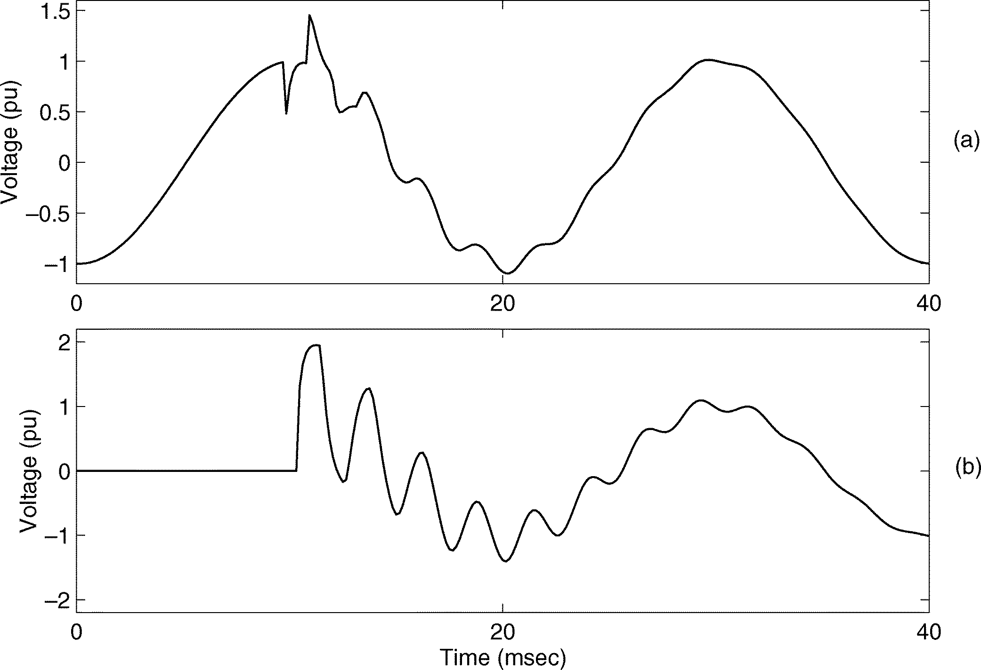

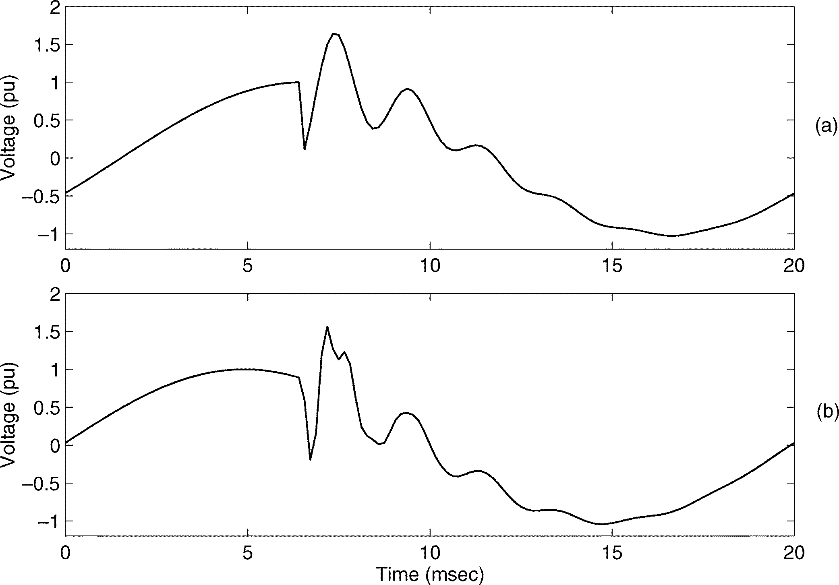Fig. 6. Voltage waveform of line energizing. From top to bottom: (a) source side; (b) end of the line.

in the same oscillations as for capacitor energizing. However such a model neglects the travelling waves that occur at the be- ginning of the transient.

Fig. 6 shows the voltage transient caused by the energizing of a 160-km open-ended line at the source side and at the end of the line. The voltage at the end of the line approaches 2.0 p.u. and this is the main concern from an insulation point of view. The overvoltage at the source side is approximately 1.4 p.u. The latter transient is the one spreading through the system and thus the one of concern from a power-quality viewpoint. In both cases there is an initial overshoot followed by an oscillatory transient in the waveform.

1. *Multiple Transients With a Single Cause*

The previously given examples all contain just one transient, due to one single switching action. However *in many cases the transient waveform is due to more than one switching action leading to overlapping transients*. During switching in a three-phase system the switching actions in the indi- vidual phases rarely take place at the same time instant. In

[5] such events are analyzed by separately considering the phase-to-phase and the phase-to-ground voltages.

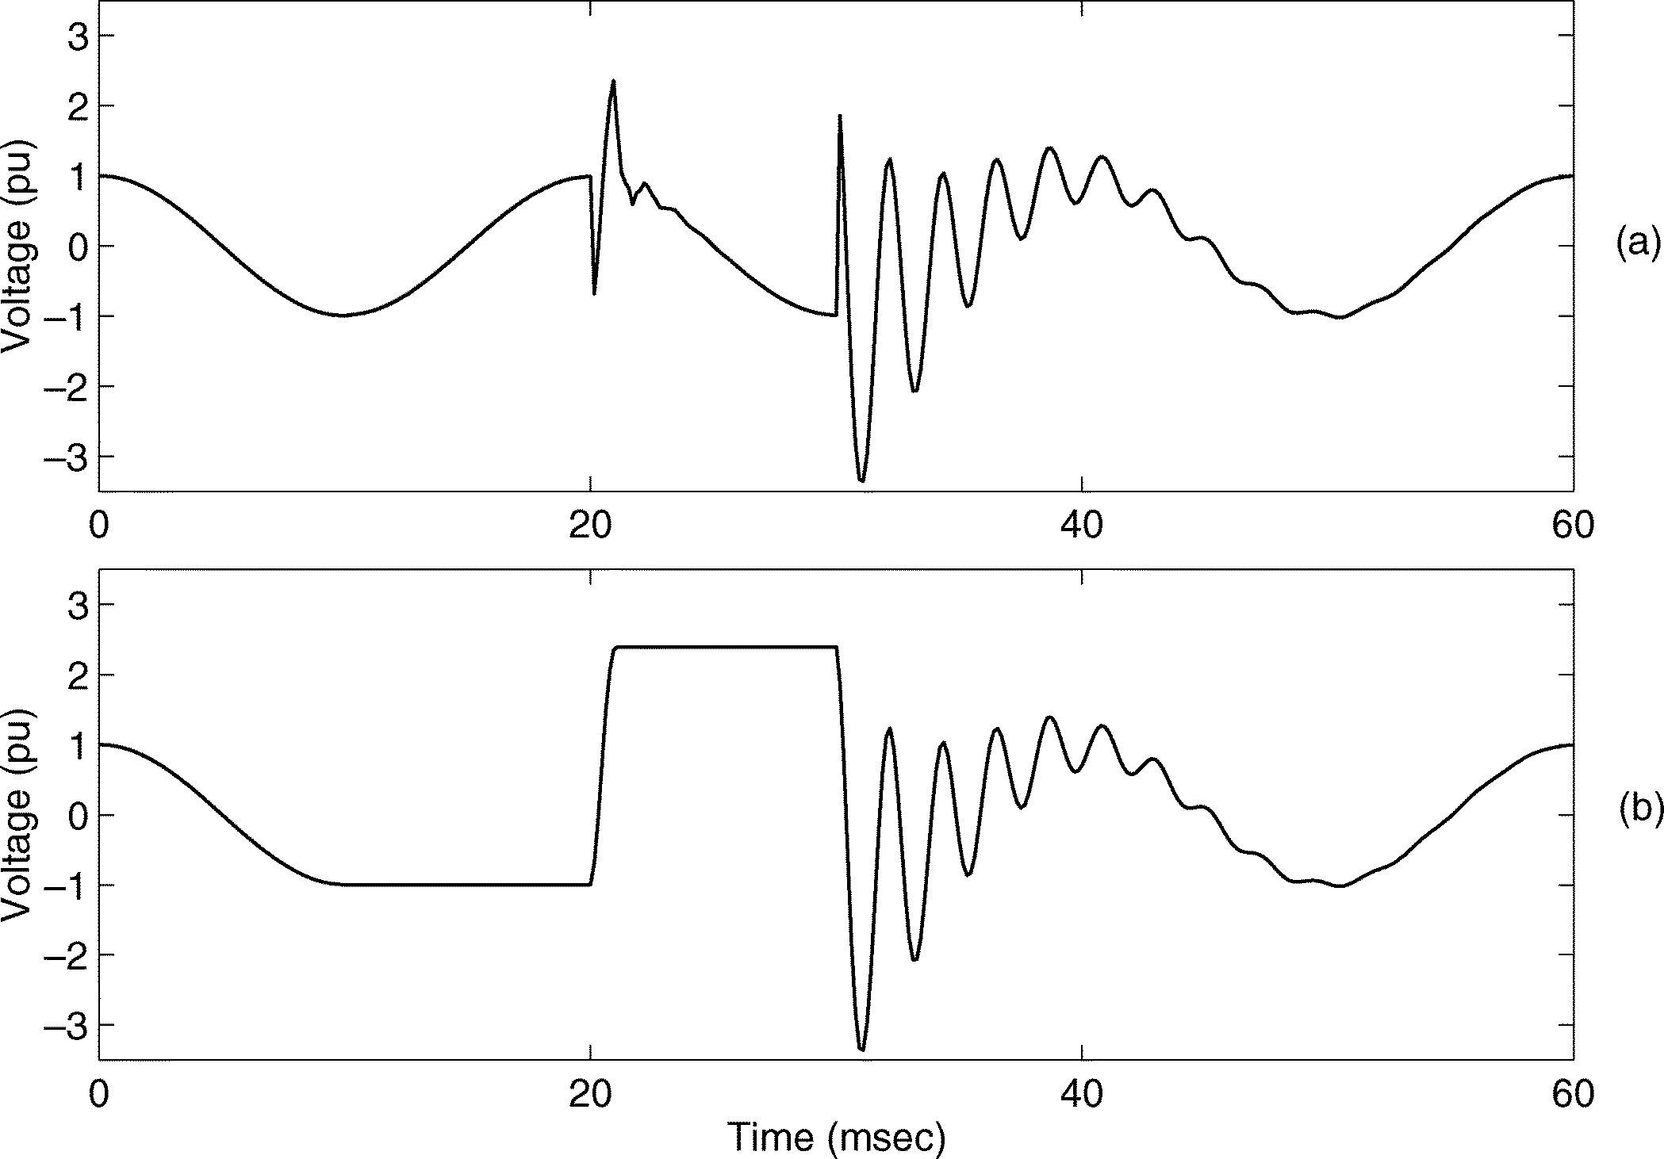

Fig. 7. Voltage waveform for multiple restrikes during capacitor de-energizing. From top to bottom: (a) line side; (b) capacitor side.

Other examples of multiple transients with a single cause are “*current chopping*” and “*restrike*.” Current chopping occurs when the current during opening of a circuit breaker becomes zero before the natural zero crossing, resulting in high overvolt- ages. Restrike may occur when a capacitor is de-energized by a slowly-moving switch. The voltage over the capacitor increases faster than the voltage-withstand of the gap between the con- tacts of the switch. An example of multiple restrikes is shown in Fig. 7. As shown in the figure multiple restrikes can lead to an escalating voltage over the capacitor leading to an internal flashover and serious damage to the equipment. Therefore it is important to detect even single restrikes at an early stage. The last row in Table I briefly summarizes some possible classes of multiple transients with a single cause.

* 1. TRANSIENT ANALYSIS

Characterizing voltage disturbances is, among others, needed to obtain information on the cause of the disturbances. In the cases of oscillatory transients, the amplitude, frequency, and damping of the dominant components are appropriate features. They can be related directly to capacitances and inductances in the system.

1. *Subband Filters*

For studying the characteristics of a signal in different fre- quency bands, time-frequency analysis can be applied. Using time-frequency analysis one may obtain the time-evolved signal components in the pre-selected frequency bands. Short-time Fourier transform (STFT) is one way of performing this kind of analysis. STFT is a time-frequency signal decomposition method which is equivalent to a set of bandpass filters with an equal bandwidth. Wavelet filters are another time-frequency (or, time-scale) analysis method that decomposes signal to time-evolved components with octave bandwidths [12]. These methods have been utilized for the analysis of power system transients [13]–[16].

Analysis using these subband filters suffers from the time-fre- quency resolution constraint (i.e., the product of time resolu- tion and frequency resolution remains a constant governed by

the uncertainty principle). One can only trade time resolution for frequency resolution [12]: a short time window provides a better time resolution but results in a bandpass filter with a larger bandwidth and, thus, worse frequency resolution. The tradeoff between the time and frequency resolution imposes problems in the analysis of signals containing components with closely spaced frequencies. An additional disadvantage is the difficulty in interpreting the resulting time-varying spectra (or spectro- gram). The human observers may be able to recognize certain patterns and relate them to types of events. However, for an au- tomatic analysis system, this is very difficult.

1. *Model-Based Approaches*

When estimating the dominant components of the signal (at unknown frequencies, which could be close to each other), high frequency-resolution model-based approaches are needed in order to estimate the frequencies and extract the frequency components. For most power-system transients the main fre- quency components are due to the resonances of the system, so that the parameters of the frequency components include information on the system and the underlying event.

Many transients can be modeled as the sum of exponentially decaying sinusoids of short duration with additive white noise

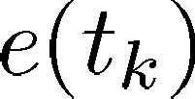

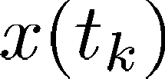 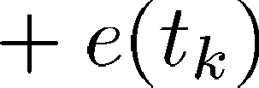 (1)

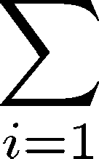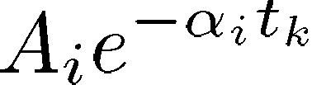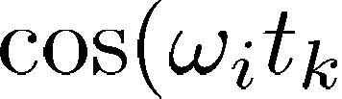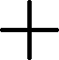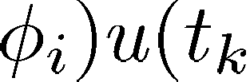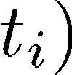

where 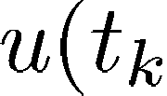  is a unit step function defined as

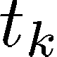 (2)

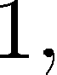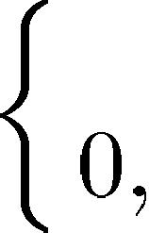

where  is an unknown parameter, and the unknown parameter vector is  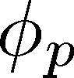 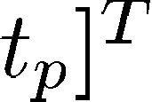. In gen-

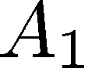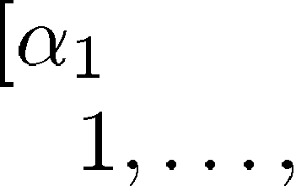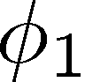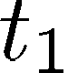

eral,  and are different (for instance, in multiple transients with a single cause described in Section II-C) and in nonsimultaneous switching to be discussed in Section III-E-IV). Prony’s method and ESPRIT are two possible ways of es- timating the parameters of such a model (the frequencies, the damping coefficients, the initial phases, and the amplitudes) under the assumption that these parameters do not change within the analysis window. Both methods can be used for the analysis of short duration transients in power systems: Prony’s method (based on pole-zero models) has been proposed for the analysis of earth fault currents [17]. In the following, we explore the ES-

PRIT method to analyze a range of transients due to different causes.

1. *ESPRIT Method: Algorithm*

Assuming that the underlying frequency components are ex- ponentially damped sinusoids, ESPRIT can be used to resolve closely spaced frequency components of a signal.

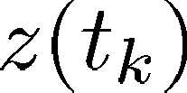ESPRIT decomposes a signal into a sum of sinusoids using the signal subspace-based approach. Consider a signal as

being the sum of exponentially damped sinusoids in additive noise

and the initial phase is the angle of , that is

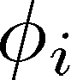 

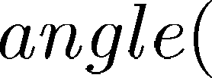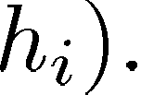

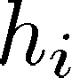(14)

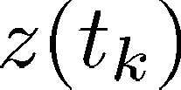 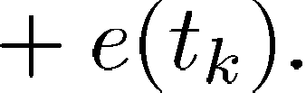 (3)

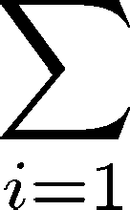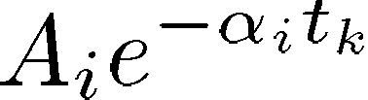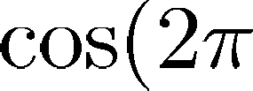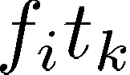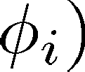

The number of sinusoids is assumed known. This is equiv- alent to (1) when   for (e.g., for cases where a single transient is caused by a single cause). The ES- PRIT method for estimating the parameters of the model can be implemented as follows [18]:

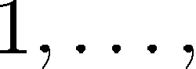

* 1. For 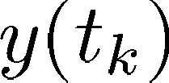 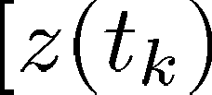 with ( ), the

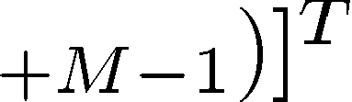

sample estimate of the corresponding covariance matrix is computed by

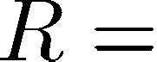(4)

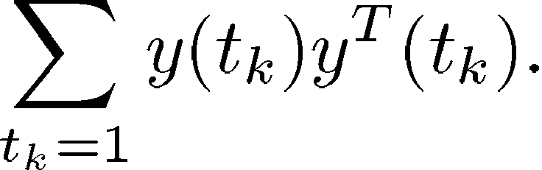

* 1. The eigenvalues ( ) and the corresponding eigenvectors ( ) of are found. The eigenvalues are arranged in de- creasing order.
  2. Considering the first eigenvectors, the matrix is formed as

(5)

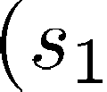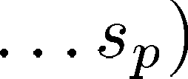

and the matrices  and  as

 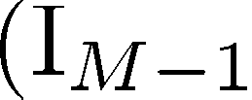   (6)

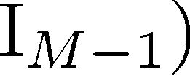

where is the identity matrix of dimension by .

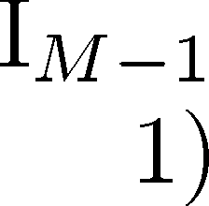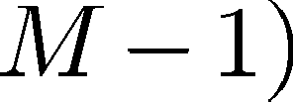

* 1. The eigenvalues of the matrix  are found. These eigenvalues ( ) determine the fre- quencies 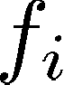 and the damping factors

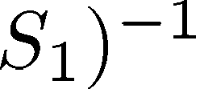

 (7)

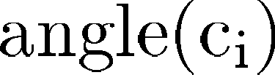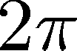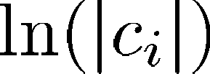

where is the sampling period.

For computing the other parameters in the model, the fol- lowing system is solved using signal samples ( ) [8]:

(8)



where

  

For real-valued signals (as the ones used next), the frequen- cies obtained by ESPRIT appear in pairs of frequencies of op- posite sign. The order of the model is therefore set to be equal to twice the number of frequencies expected in the signal.

1. *Implementation Issues*

For the examples discussed in the next section, prefiltering is applied to the voltage waveforms before applying ESPRIT. First, a highpass linear-phase finite-impulse-response (FIR) filter [19] with 128 taps and a cutoff frequency of 200 Hz is applied to remove the fundamental frequency component. For most practical cases, the fundamental frequency component is predominant: ten to 100 times larger than the remaining components. This may lead to large estimation errors for the relatively weaker signal components when using ESPRIT. Prefiltering is shown to be a practically useful approach to resolve this problem. As long as the frequencies of transient components under consideration are much higher than the fun- damental frequency, the artifacts of prefiltering are negligible for the transient analysis. If the frequency of transient is close to the power system fundamental frequency, a notch filter at the fundamental frequency can be used.

As mentioned before, it is important that the ESPRIT method be applied to a window in which the relevant parameters of the signals are stationary. This requires that the beginning and ending points of the transient are found. In the examples to be discussed in Section III-E, the method described in Section III-C is applied to the data interval that starts from the point of the first local maximum value in the voltage and ends where the tran- sient is completely damped. Alternative methods for automatic detection of such an interval may include using wavelets to find the corresponding singular points [12], or using a segmentation method that exploits Kalman filter residues [20]. To limit the scope of this paper, the interval is currently chosen manually (which is rather straight forward in offline processing). Exam- ples of manually selected intervals are shown in Figs. 10–12 and 14 where the time indices in (b) indicate the selected time interval from the original signal in (a). The first half of the data within the interval is used for the estimation of the frequencies  and the damping factors , and the whole data interval for the estimation of  and . Choosing the starting point of the



  

.

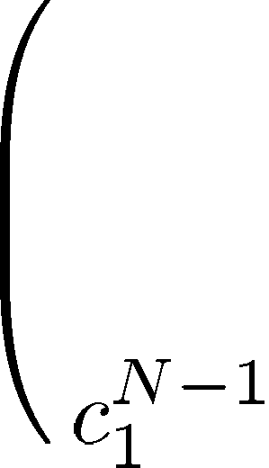

.

.

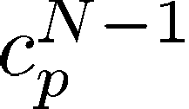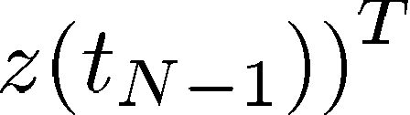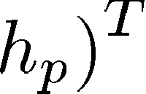

. .

. .

.

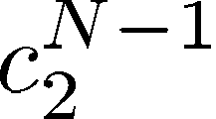 

  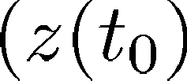 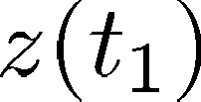 

  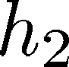 

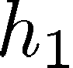

The least squares solution to (8) is



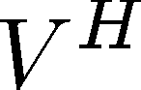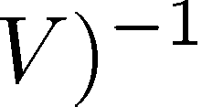

Having computed , the amplitude is calculated as

 

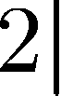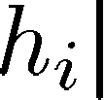

(9)

(10)

(11)

(12)

(13)

transient too early may result in the capture of travelling waves or the difference in switching instants in different phases; thus, it may lead to unreliable results. Delaying the starting point does not affect the results. As long as the basic assumption holds (i.e., the transient consists of damped sinusoids), a later starting point will only reduce the signal–noise ratio but not the frequency and damping of the components.

After parameter estimation, the transient is reconstructed using the obtained results and (3). The reconstructed signal is used to indicate how well the original transient is mod- eled and how accurate the parameters are estimated. This can be measured by using mean square error (MSE) cri- terion between the original and the reconstructed signals

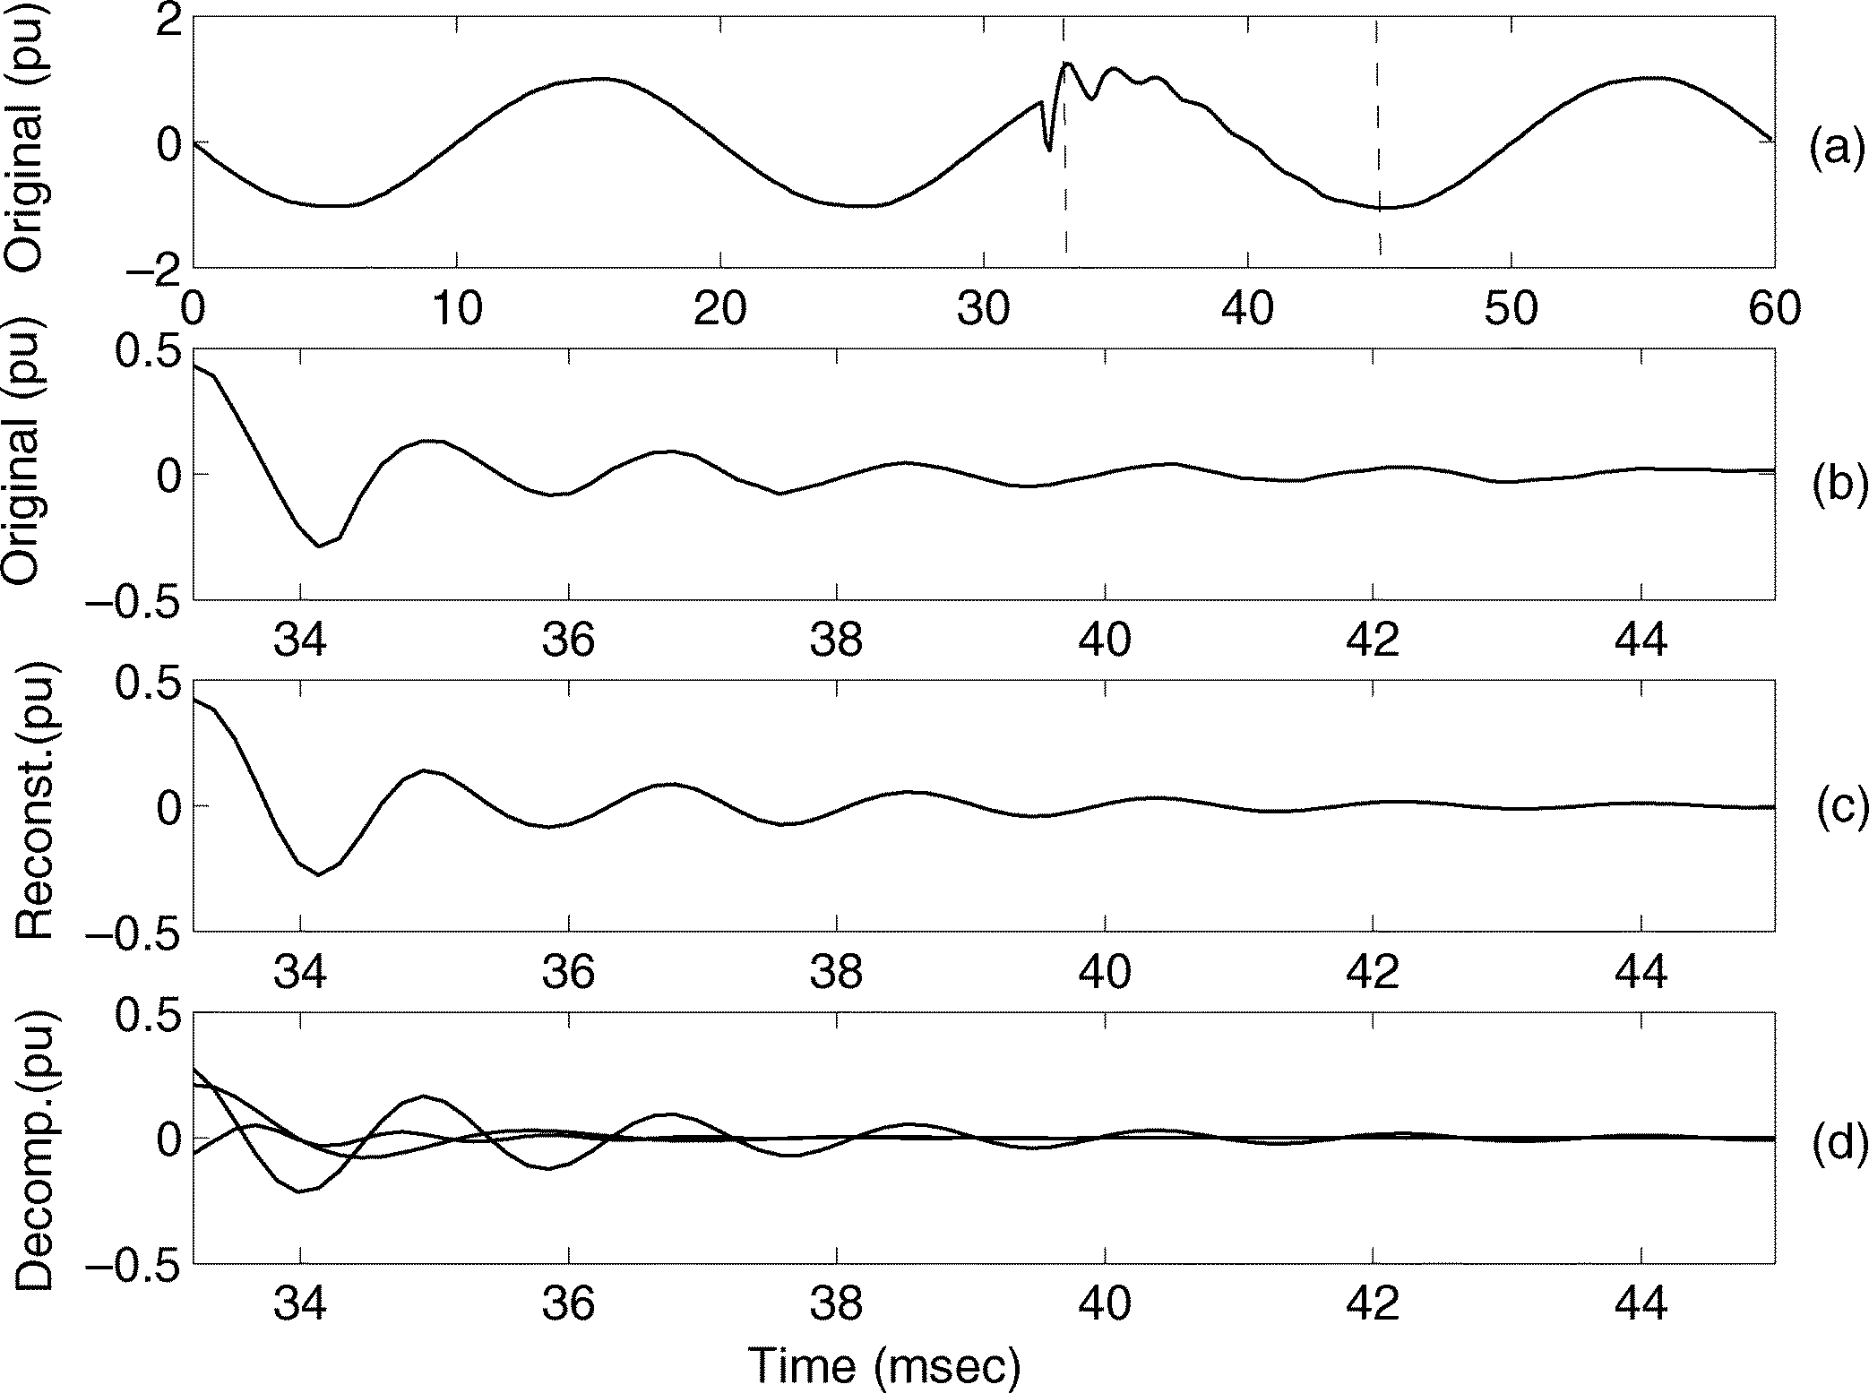 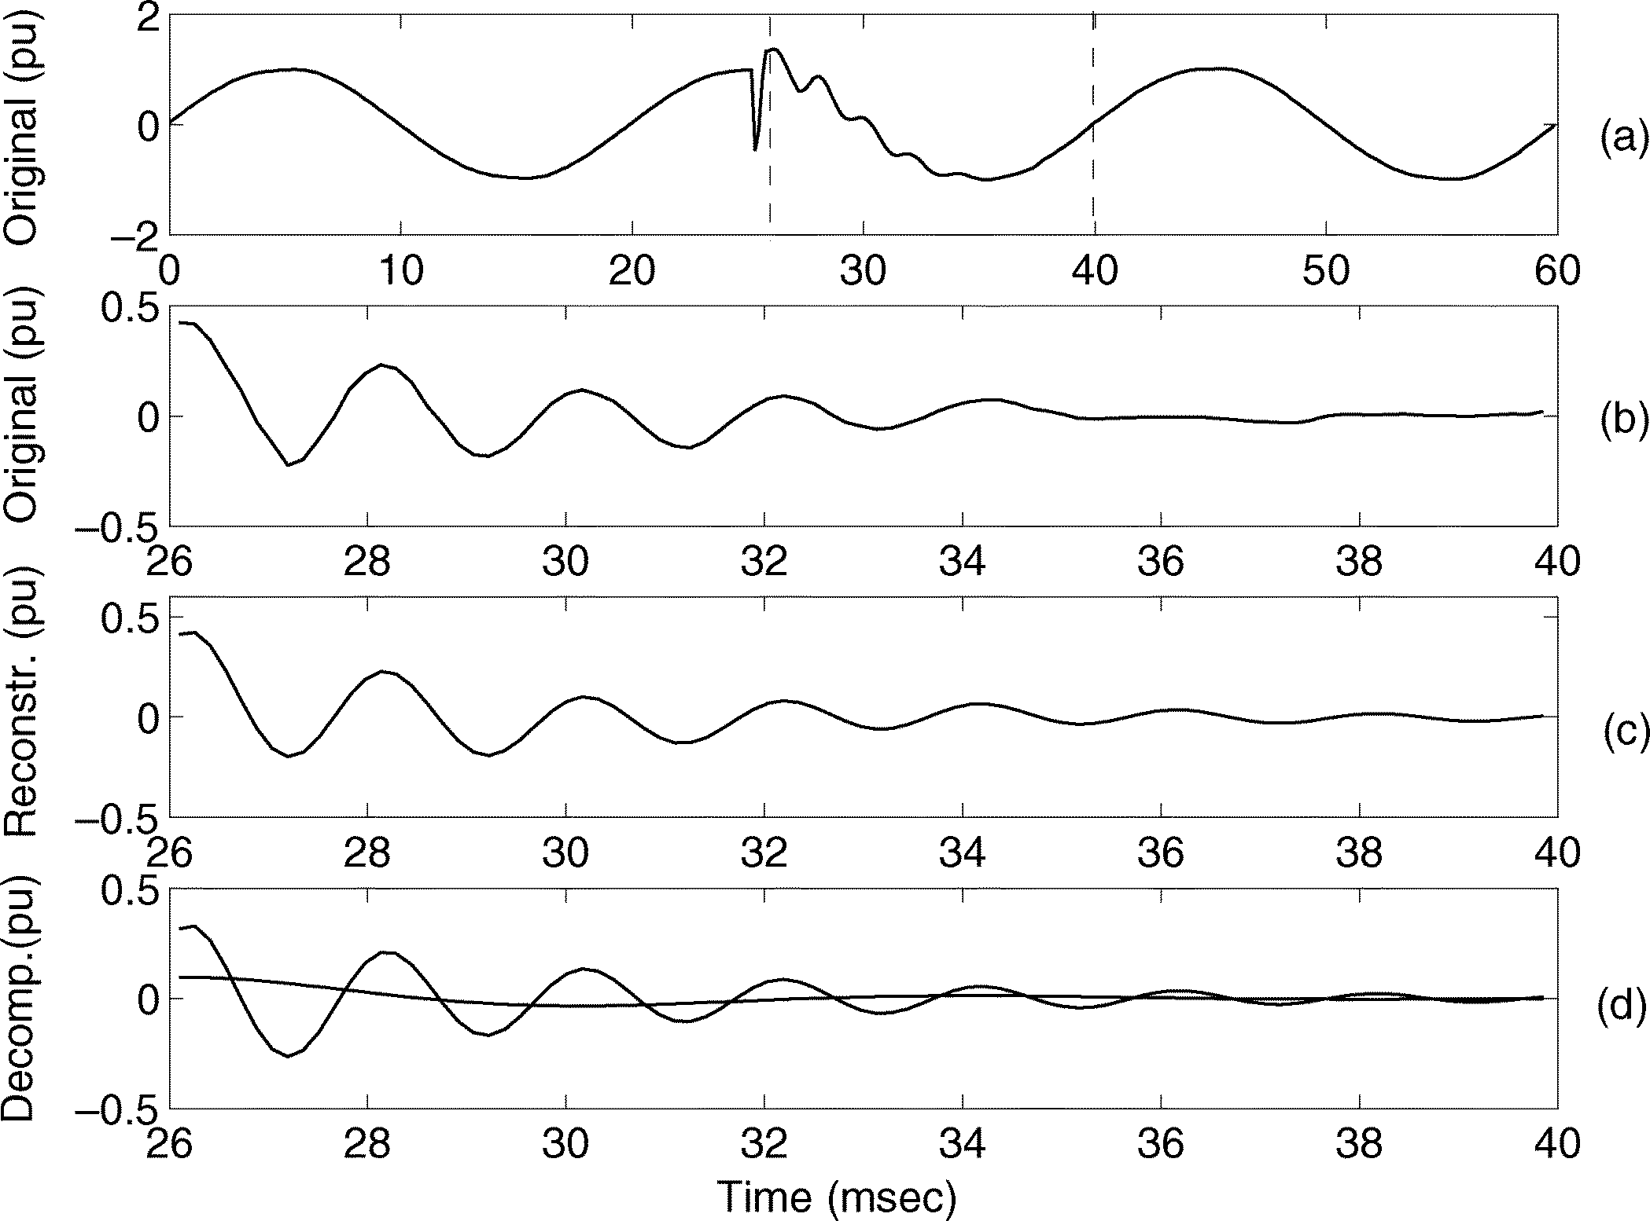

Fig. 8. Analyzing a transient data sequence from measurement. (a) Original signal. (b) Part of the signal used for analysis. (c) Reconstructed signal using ESPRIT results. (d) Three decomposed components from ESPRIT with f = 403, f = 550, and f = 907 Hz.

Fig. 9. Analyzing a transient data sequence from measurement. (a) Original signal. (b) Part of the signal used for analysis. (c) Reconstructed signal using ESPRIT results. (d) Two decomposed components from ESPRIT with f =126, f =501 Hz.

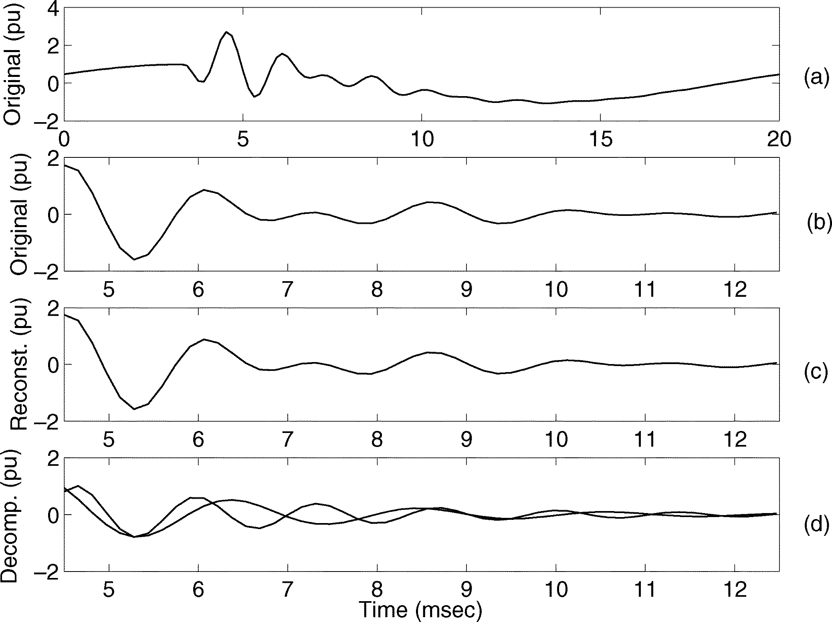, where is the total number of

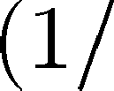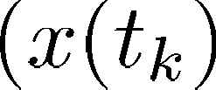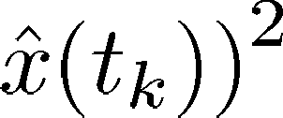

samples used for analysis.

The order of the model in (3) (the number of damped si- nusoids in the signal) is set by the user. The best model order can be determined empirically once the model noise 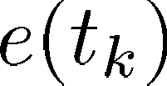 in

(3) is small and close to white [21]. For the results shown next, the order of the model in (3) is set as high as needed to re- duce the maximum difference between the original transient and the reconstructed transient below 5% of the maximum value of the transient. For the examples shown next, the simulations pre- sented in the previous sections are used.

1. *Examples*
   1. *Analysis of Transients From Measurement Data:* Fig. 8 shows the original transient data from the measurement, the three major frequency components obtained from ESPRIT and the reconstructed signal. The frequencies of these three com- ponents are 403, 550, and 907 Hz. The transient was measured in a low-voltage system and was due to nearby capacitor ener- gizing. The peak of the voltage is due to the summation of a 550- and a 403-Hz component. The latter is, however, damped rather quickly so that the 550 Hz dominates after a few millisec- onds. The 11th harmonic is less than 0.5% before and after the event so that it does not significantly affect the estimation of the damped 550-Hz component.

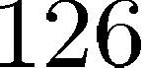Fig. 9 shows the original transient data from the measure- ment, the two major frequency components obtained from ES- PRIT and the reconstructed signal. The transient was measured in a low-voltage system from the same location as the above ex- ample, and was also due to nearby capacitor energizing. In this case, the frequencies of the two decomposed components are 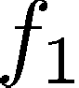 and 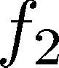 , where the latter one is dominating. A more detailed interpretation from the decomposed compo- nents will require some *a priori* power system information. In the subsequent examples, we shall use synthetically generated data with some preselected power system settings from using



Fig. 10. Analyzing a transient due to the capacitor energizing with voltage amplification. (a) Original signal. (b) Part of the signal used for analysis.

(c) Reconstructed signal using ESPRIT results. (d) Two decomposed components from ESPRIT with f =477, f = 742 Hz and in-phase.

EMTP in order to show how the results from ESPRIT can be interpreted with the help of some system information.

* 1. *Analysis of Voltage Amplification due to Capacitor Ener- gizing:* Fig. 10 shows the results of ESPRIT for the transient that corresponds to the voltage amplification case of Fig. 3(b). ESPRIT successfully resolves the two peak frequencies in the spectrum of transient (Fig. 4). The frequencies of the two si- nusoids are found to be 477 and 742 Hz. At the beginning of transient, the two sinusoids are in phase, contributing equally to the resulting overvoltage. This feature obtained, after applying ESPRIT, can be used for identifying the voltage amplification phenomenon: there are two strong frequency components that contribute significantly to the overvoltage in this low voltage transient.

Fig. 11 shows the analysis results for a transient corre- sponding to the voltage in Fig. 5(b). Two sinusoids are found to be adequate in modeling the signal (frequencies 484 and

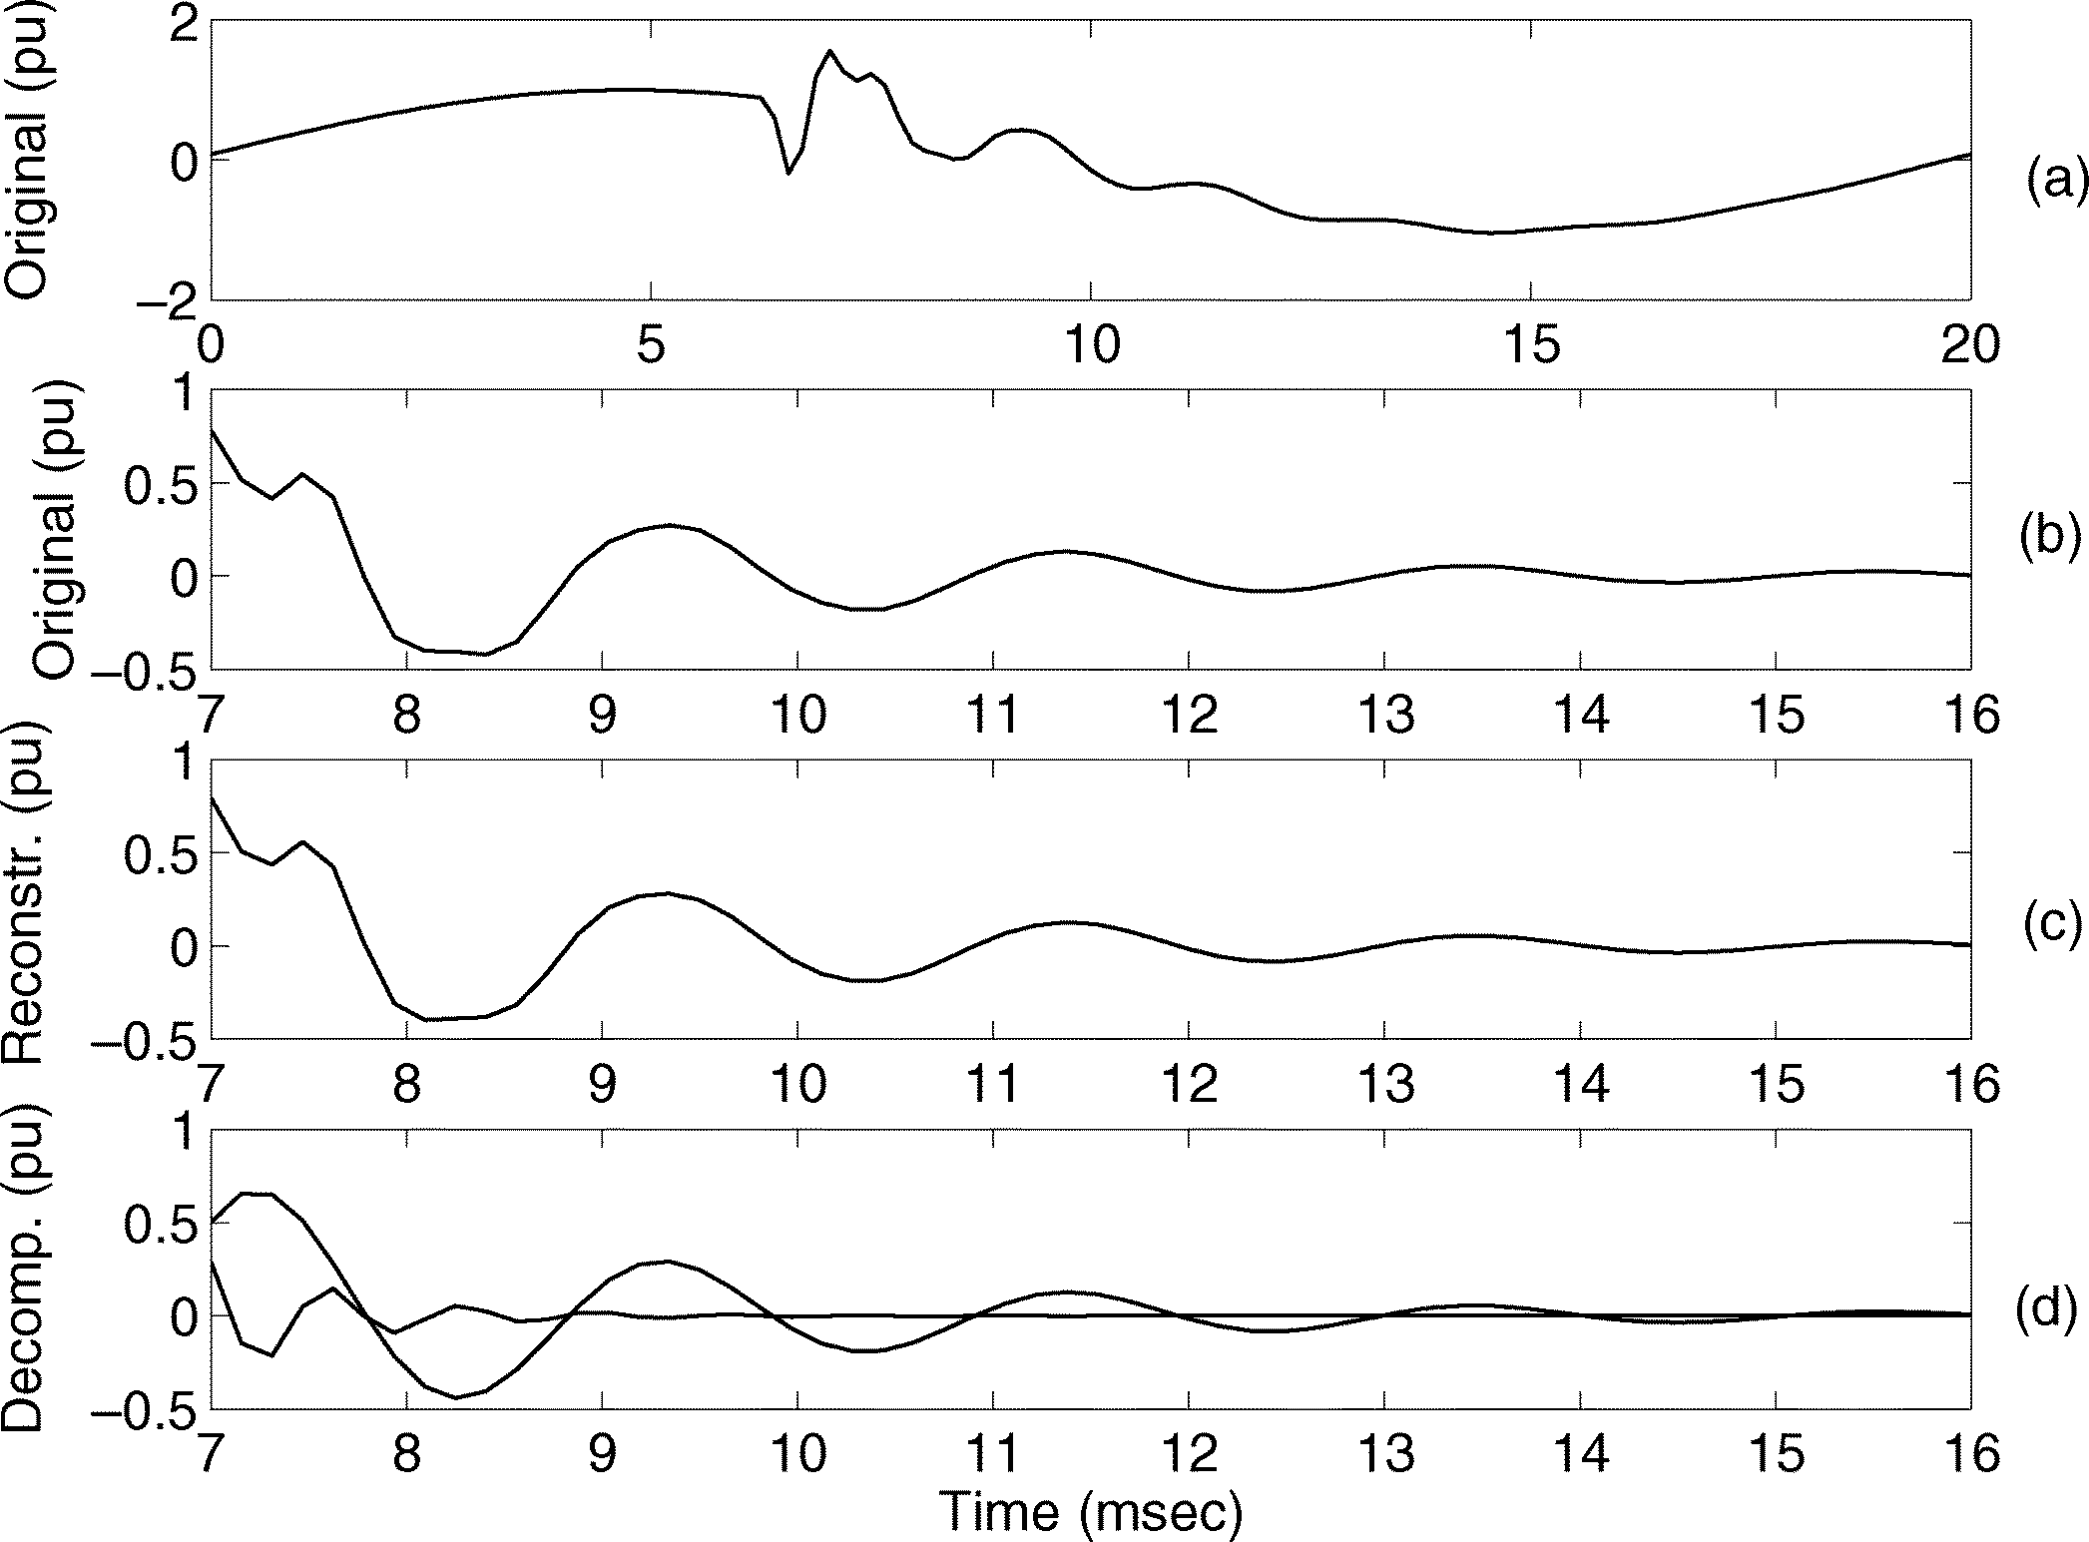 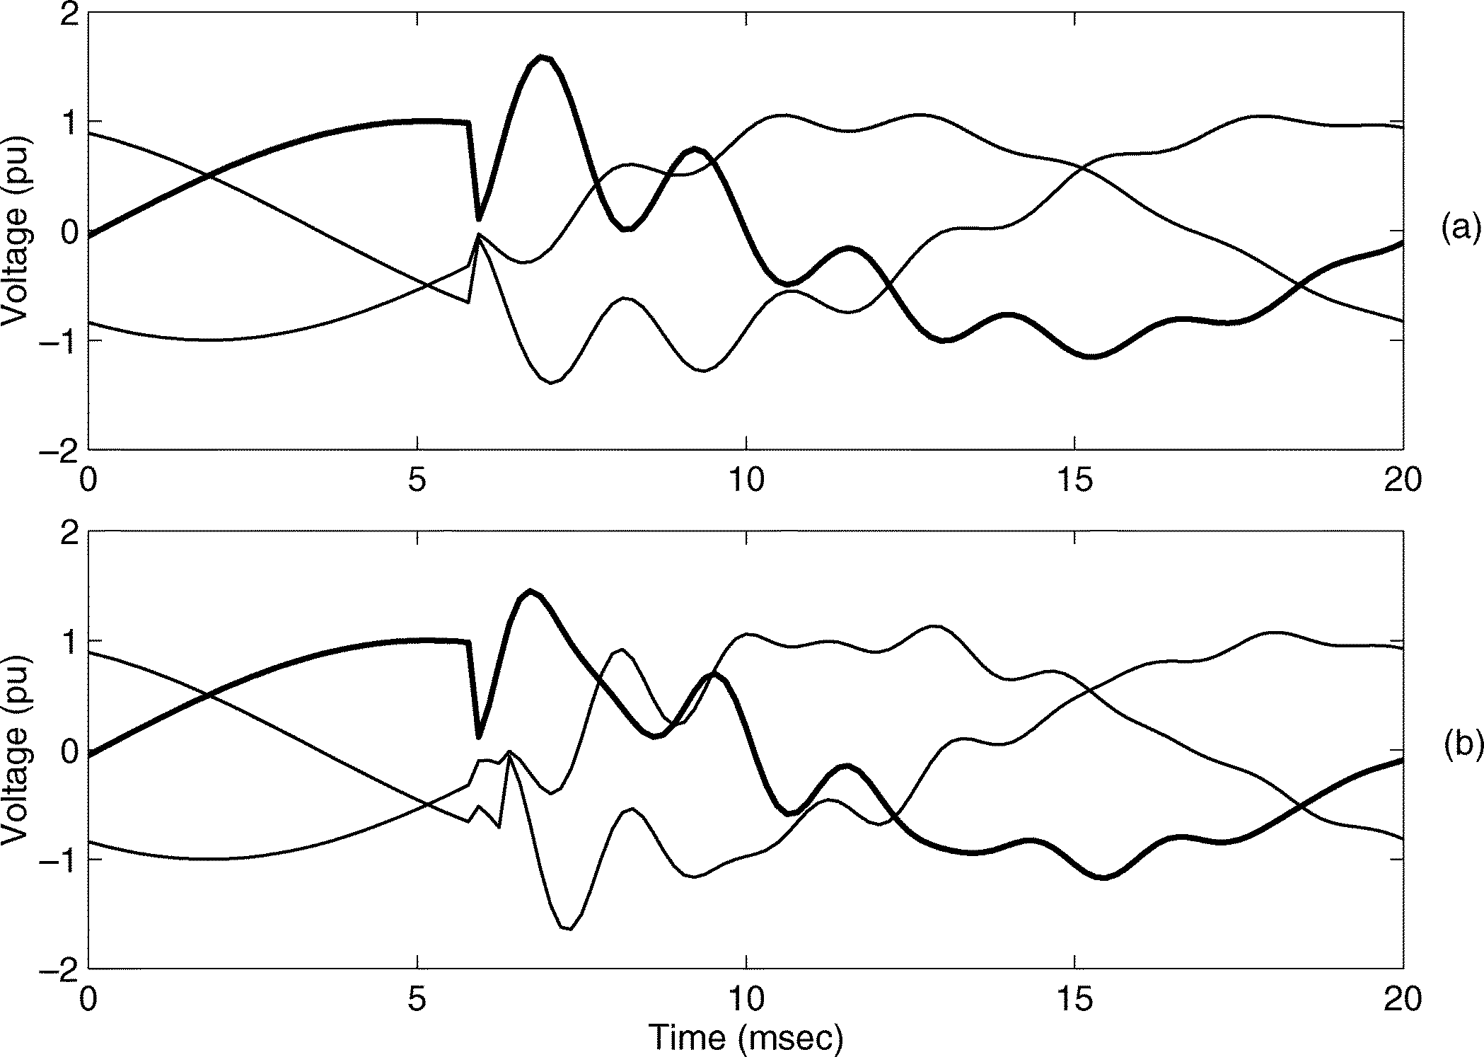

Fig. 11. Analyzing a transient due to capacitor energizing without causing voltage amplification. (a) Original signal. (b) Part of the signal used for analysis. (c) Reconstructed signal using ESPRIT results. (c) Two decomposed components from ESPRIT with frequency f =474, f = 1507 Hz and almost in opposite phases.

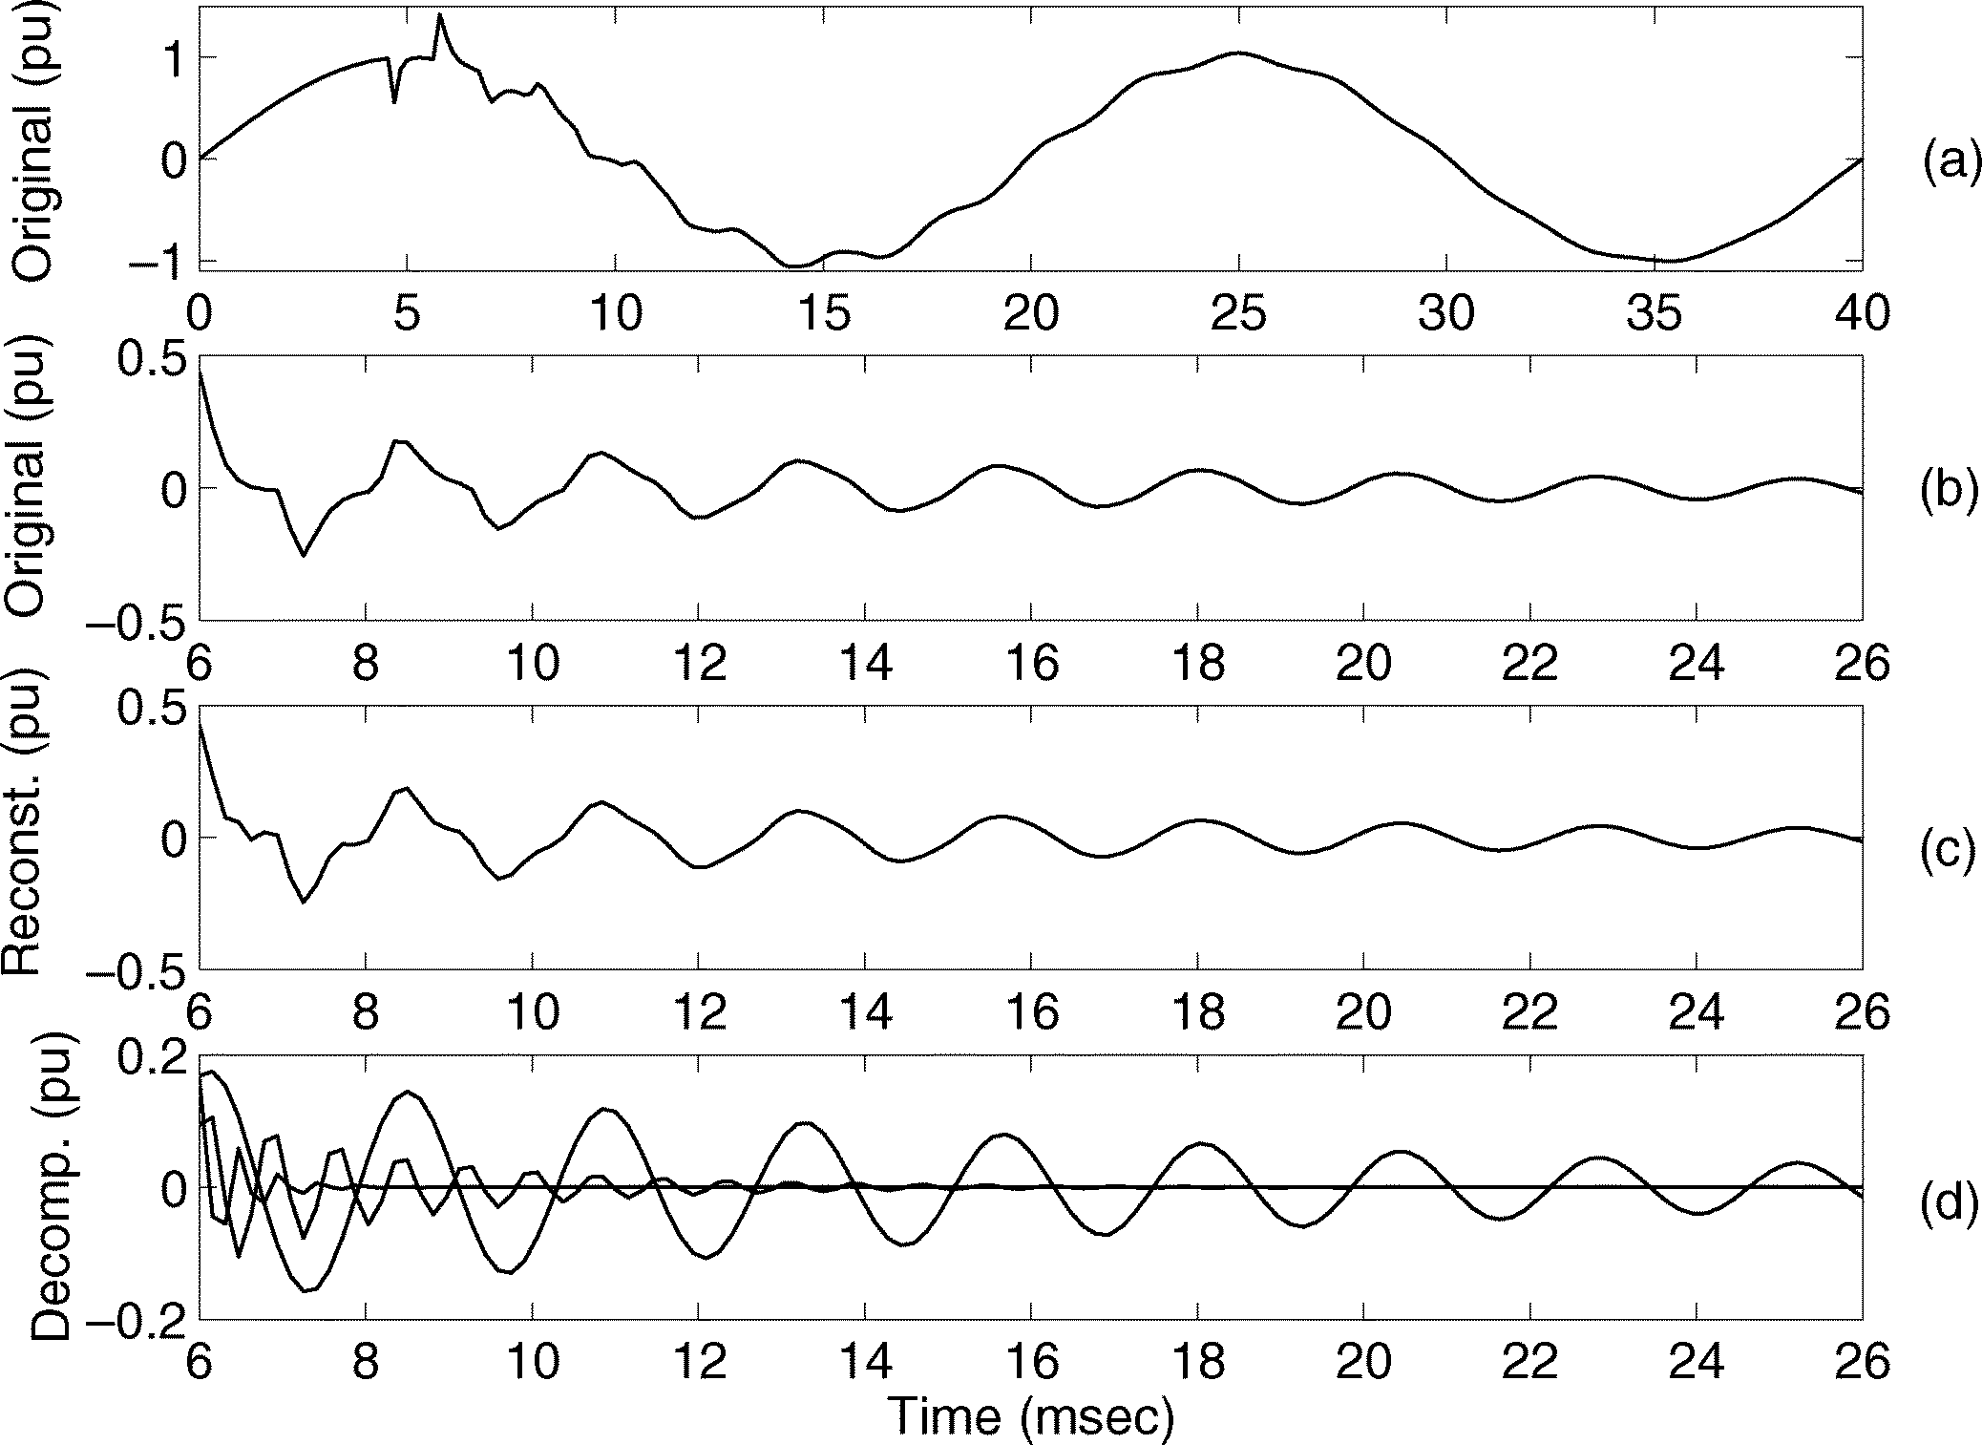

Fig. 12. Decomposition of a transient due to line energizing. (a) Original signal. (b) Part of the signal used for analysis. (c) Reconstructed signal using ESPRIT results. (d) Three decomposed components from ESPRIT: a strong low-frequency component of 418 Hz, and two fast decay high-frequency components of 1283 and 1865 Hz.

1507 Hz). However, the higher frequency sinusoid has a low magnitude, decays fast, and its phase is almost opposite to the phase of the other sinusoid. Consequently, the resulting overvoltage is significantly lower than that in Fig. 10. In this case, the low voltage capacitor bank does not cause voltage amplification.

* 1. *Analysis of Transients due to Line Energizing:* Fig. 12 shows the results from ESPRIT for a transient due to line ener- gizing (see Fig. 6). The decomposition result shows that there is one strong frequency component (418 Hz) and two other fast de- caying sinusoids of higher frequencies (1283 and 1865 Hz). The effect of travelling waves on the voltage waveform can be seen from the sinusoidal model. It is important to notice that these two sinusoids initially contribute almost equally to the voltage maximum as the lower-frequency sinusoid. This indicates that the maximum voltage in the case of line energizing is not due to

Fig. 13. Voltage waveforms for a multiple-transient with a single cause of capacitor energizing. From top to bottom: (a) with simultaneous capacitor energizing; (b) with nonsimultaneous capacitor energizing. (thicker line: phase a) (transient waveforms were obtained from ATP-EMTP simulation).

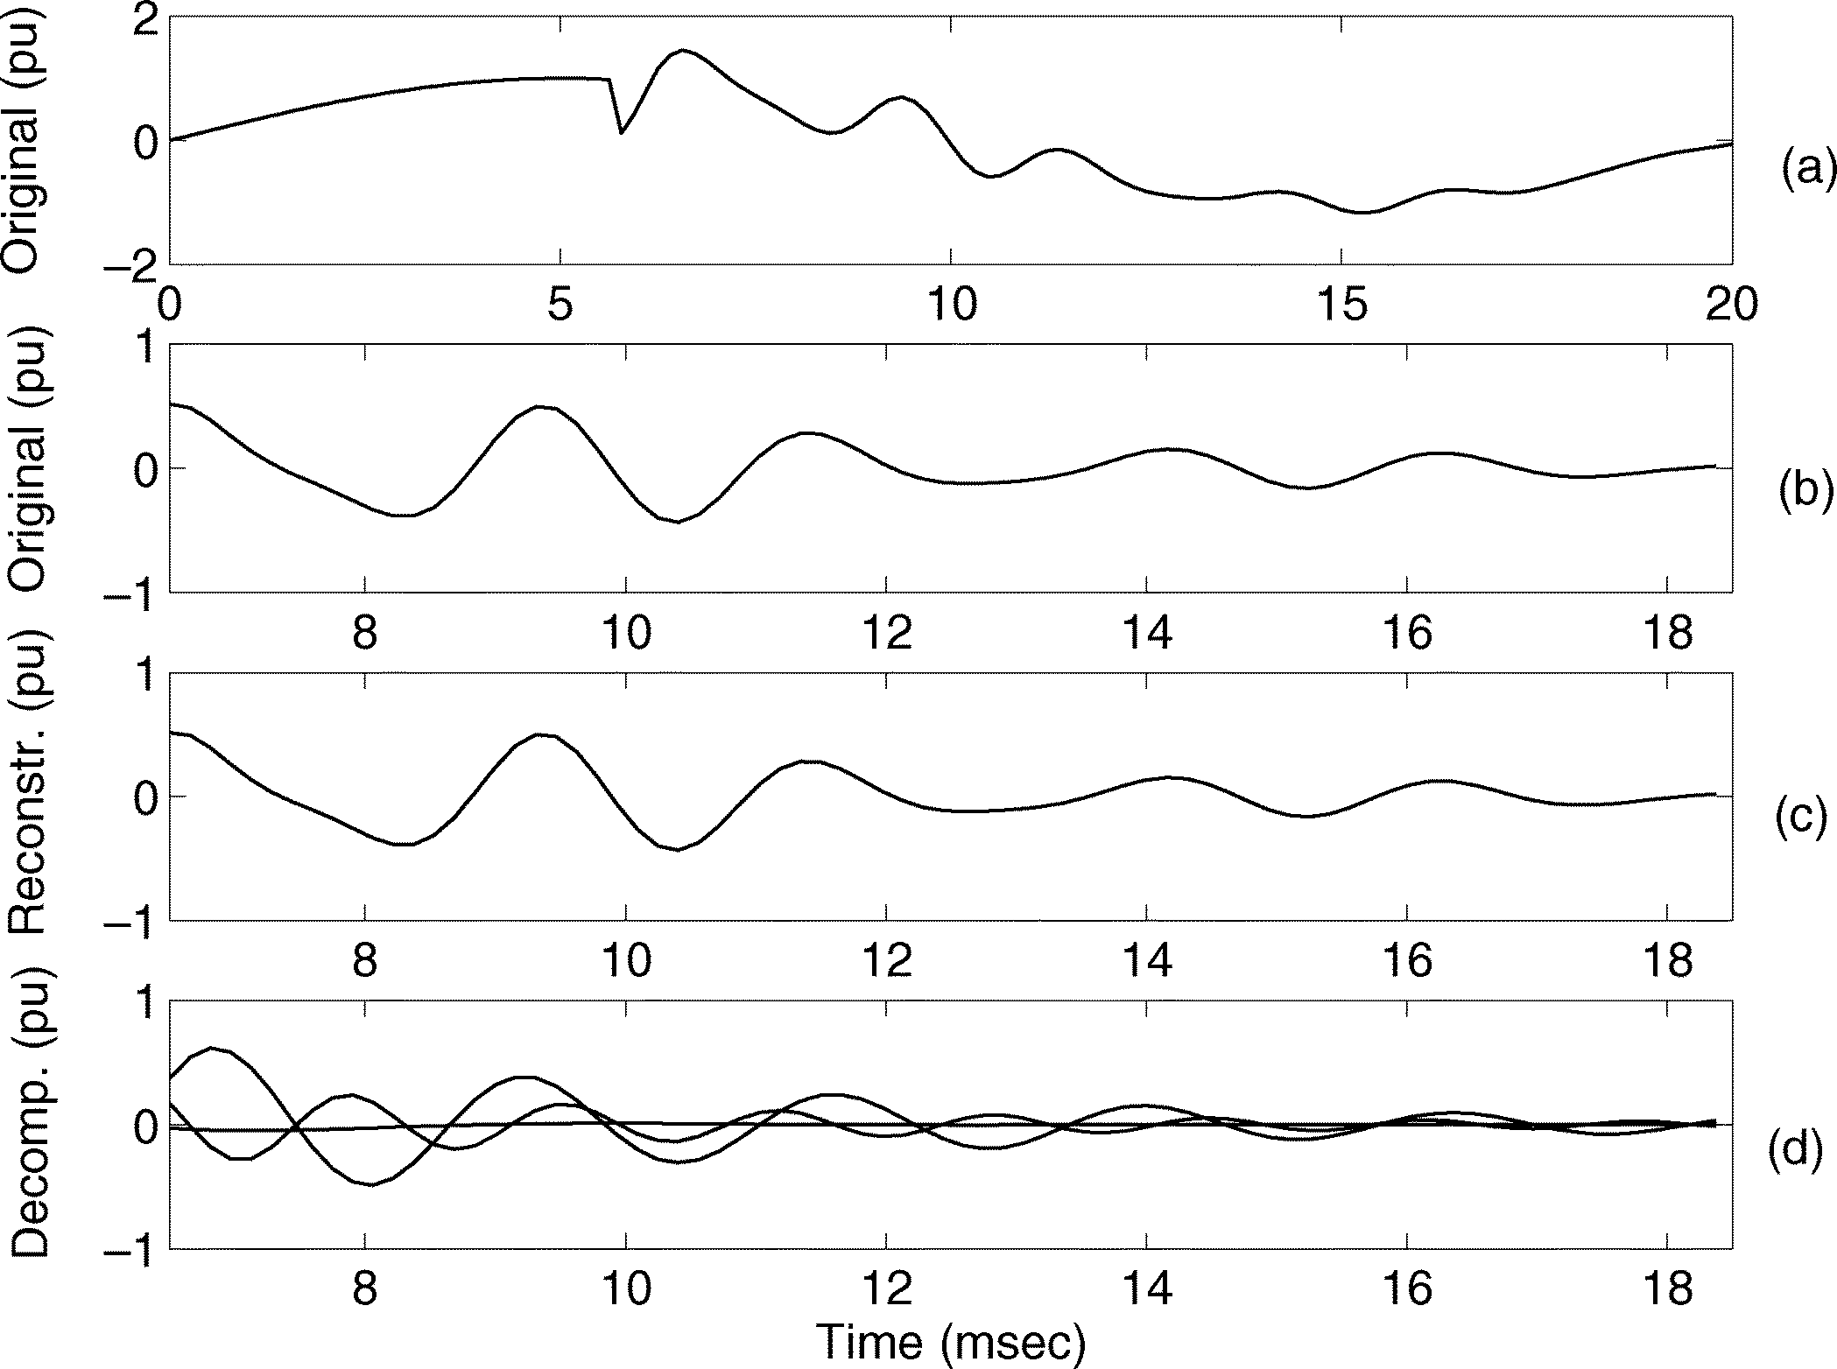

Fig. 14. Decomposition of a transient due to nonsimultaneous capacitor energizing. (a) Original signal. (b) Part of the signal used for analysis.

(c) Reconstructed transient using ESPRIT. (d) Three components obtained from using ESPRIT with frequencies 181, 420, and 605 Hz.

the long-duration, low-frequency oscillation but due to the ar- rival of travelling wave from the open end of the line. As can be seen, the sinusoids model shows that the travelling wave decays fast.

* 1. *Analysis of the Influence of Nonsimultaneous Switch- ing:* Nonsimultaneous switching is a special case of multiple transients with a single cause. The influence of different switching angles between phases is studied here. For all of the test results shown previously, the three phases are switched at exactly the same time instant.

Fig. 13 shows the three phase voltages for a simultaneous switching case and the nonsimultaneous switching case. For the nonsimultaneous switching case, the switching angles of the three phases are not the same: phase a is switched first and phases b and c are switched 0.5 ms later. It can be seen that the resulting waveforms differ considerably, and that the switching of one phase induces transients to the other two.

The results of ESPRIT for phase a in Fig. 14 show that the transient can be decomposed into three sinusoids. The highest energy sinusoid has a frequency of 420 Hz, almost equal to the frequency of the highest energy sinusoid of the decomposition of the simultaneous switching case. From the other two sinu- soids, one has significant energy (frequency of 605 Hz). This frequency component is induced by the switching of phases b and c. The other very low energy sinusoid (frequency of 181 Hz) models the influence of the travelling waves.

It should be noted that ESPRIT is applied to a part of the tran- sient that starts after all switching actions are completed. Fur- ther, it should be noted that using the sinusoidal model (3) in ESPRIT implies that all components start at the same time in- stant; therefore, if a transient under analysis contains frequency elements that start later, then the results of ESPRIT will not be reliable.

* 1. DISCUSSIONS

*Where ESPRIT is Suitable:* In the paper, we propose sinu- soidal models for *oscillatory transients* and analyze the models by using ESPRIT. The basis is that oscillatory transients can be modeled by damped sinusoids, where ESPRIT is based upon. As long as the model fits the signal well, ESPRIT provides good estimation for dissolving signal components at closely spaced frequencies. However, for impulsive transients, ESPRIT is not a suitable analysis tool. It should be noted that the major com- ponents of transients obtained from ESPRIT provide a means of identifying the possible causes of transients. A successful in- terpretation is much dependent on how well one can correlate the information from these components with the possible phe- nomena in different types of transients by combining possible *a priori* knowledge of some power system settings.

*Advantages:* ESPRIT uses damped sinusoidal signal mod- eling and is able to provide good estimation of signal compo- nents with a very-high-frequency resolution for signals in noise. Since many oscillatory transients do obey the damped sinu- soidal models, ESPRIT is therefore the best choice among the existing signal processing methods. An alternative method is to use MUltiple SIgnal Classification (MUSIC) that also employs damped sinusoidal model [21]. However, MUSIC is considered less reliable as it is based on the noise subspaces.

Comparing ESPRIT with a nonmodel-based method (e.g., FFT or STFT), the latter has a relatively low frequency reso- lution, and is not suitable to estimate signal components at ar- bitrary frequencies. In addition, when the noise is present, the performance is rather poor. Wavelet is another nonmodel-based method that decomposes signal into subband components; how- ever, it cannot resolve signal components within the same band [14].

*Limitations:* Since ESPRIT uses the damped sinusoidal model in (3), it implies that all signal components start at the same time instant. However, this is not always the case. When a transient is the sum of multiple time-delayed transients either with a single or multiple causes (Section II-C and the last example in Section III-E), one needs to use a more gen- eral damped sinusoidal model as described in (1). However, ESPRIT has so far not been able to provide a solution to such

a case, and the problem remains an open research topic for signal processing research. Some possible approaches (e.g., wavelets[12], segmentation [20], and sliding-window ESPRIT), can be explored to find the starting time instants of different components.

The method presented in this paper only analyzes oscillatory types of transients that can be modeled as damped sinusoids in noise. Modeling and analysis of impulsive transients remain an open research issue and is beyond the scope of this paper. Ex- amples are given in the paper on analyzing transients caused by capacitor switching and line energizing, which are by far com- plete. As mentioned previously, finding the underlying causes of transients remains a difficult task and is in the very early stage of research.

*Future Research:* Future research on transient analysis in- cludes automatically detecting the start and end of a transient; analyzing multiple transients with a single cause or multiple cause; and extracting information from travelling waves. Other important open issues on transient analysis, among many others, include modeling and analyzing impulsive transients; modeling power-system components at high frequencies (e.g., few kilo- hertz); characterizing transients for performance specification of power systems and for understanding their effect on the end- user equipment.

* 1. CONCLUSIONS

Power system transients appear in different waveform shapes and are caused by different underlying reasons. In order to better understand their origins, it is important to analyze transients ac- cording to their underlying causes (or events). A preliminary categorization has been given (Table I) where impulsive, oscil- latory, and multiple transients are further classified according to their underlying causes. The paper then concentrates on an- alyzing and interpreting oscillatory transients based on such a philosophy. We modeled the oscillatory transients as the sum of damped sinusoids, where the signal processing method ES- PRIT is well suited for the decomposition of such transients with high-frequency resolution. The decomposed components of damped sinusoids can be used to extract information or to interpret the underlying causes and, hence, for the diagnostics of power system transients. Examples have been given for ana- lyzing transients due to capacitor switching and line energizing, where phenomena and characteristics are interpreted and associ- ated with the underlying causes. We also mention the limitation of ESPRIT analysis and some future research that requires more advanced signal processing and more insight on power system transients.

REFERENCES

1. A. Greenwood, *Electrical Transients in Power Systems*. New York: Wiley, 1991.
2. L. van der Sluis, *Transients in Power Systems*. New York: Wiley, 2001.
3. A. R. Hileman, *Insulation Coordination for Power Systems*. New York: Marcel Dekker, 1999.
4. R. C. Dugan, M. F. McGranaghan, and H. W. Beaty, *Electric Power Systems Quality*. New York: McGraw-Hill, 1996.
5. E. Styvaktakis, “Automating power quality analysis,” Ph.D. thesis, Dept. Signals Syst., Chalmers Univ. Technol., Gothenburg, Sweden, 2002.
6. M. H. J. Bollen, *Understanding Power Quality Problems: Voltage Sags and Interruptions*. Piscataway, NJ: IEEE Press, 2000.
7. R. Roy, A. Paulraj, and T. Kailath, “ESPRIT-A subspace rotation ap- proach to estimation of parameters of sinusoids in noise,” *IEEE Trans. Acoust., Speech, Signal Processing*, vol. 34, no. 5, pp. 1340–1342, Oct. 1986.
8. J. Dafis, C. O. Nwankpa, and A. Petropoulu, “Analysis of power system transient disturbances using an ESPRIT-based method,” in *Proc. IEEE Power Engineering Soc. Summer Meeting*, 2000, pp. 437–442.
9. *IEEE Recommended Practice for Monitoring Electric Power Quality*, IEEE Standard 1159-1995.
10. C. A. Nucci, F. Rachidi, M. V. Ianoz, and C. Mazzetti, “Lightning-in- duced overvoltages and overhead lines,” *IEEE Trans. Electromagn. Compat.*, vol. 35, no. 1, pp. 75–86, Feb. 1993.
11. D. M. Dunsmore, E. R. Taylor, B. F. Wirtz, and T. L. Yanchula, “Magnifi- cation of transient voltages in multi-voltage-level, shunt-capacitor-com- pensated circuits,” *IEEE Trans. Power Del.*, vol. 7, no. 2, pp. 644–673, Apr. 1992.
12. O. Rioul and M. Vetterli, “Wavelets and signal processing,” *IEEE Signal Processing Maga.*, vol. 8, no. 4, pp. 14–38, Oct. 1991.
13. S. Santoso, W. M. Grady, E. J. Powers, J. Lamoree, and S. C. Bhatt, “Characterization of distribution power quality events with Fourier and wavelet transforms,” *IEEE Trans. Power Del.*, vol. 15, no. 1, pp. 247–254, Jan. 2000.
14. I. Y. H. Gu and M. H. J. Bollen, “Time-frequency and time-scale domain analysis of voltage disturbances,” *IEEE Trans. Power Del.*, vol. 15, no. 4, pp. 1279–1284, Oct. 2000.
15. G. T. Heydt, P. S. Fjeld, C. C. Liu, D. Pierce, L. Tu, and G. Hensley, “Ap- plications of the windowed FFT to electric power quality assessment,” *IEEE Trans. Power Del.*, vol. 14, no. 4, pp. 1411–1416, Oct. 1999.
16. O. Poisson, P. Rioual, and M. Meunier, “Detection and measurement of power quality disturbances using wavelet transform,” *IEEE Trans. Power Syst.*, vol. 15, no. 3, pp. 1039–1044, Jul. 2000.
17. O. Chaari, P. Bastard, and M. Meunier, “Prony’s method: An efficient tool for the analysis of earth fault currents in Petersen-coil-protected networks,” *IEEE Trans. Power Del.*, vol. 10, no. 3, pp. 1234–1241, Jul. 1995.
18. A. Eriksson, P. Stoica, and T. Soderstrom, “Second-order properties of MUSIC and ESPRIT estimates of sinusoidal frequencies in high SNR scenarios,” *Proc. Inst. Elect. Eng., Radar Signal Processing*, vol. 140, no. 4, pp. 266–272, Aug. 1993.
19. J. Proakis and D. Manolakis, *Digital Signal Processing: Principles, Algorithms and Applications*. Upper Saddle River, NJ: Prentice-Hall, 1996.
20. E. Styvaktakis, M. H. J. Bollen, and I. Y. H. Gu, “Expert system for classification and analysis of power system events,” *IEEE Trans. Power Del.*, vol. 17, no. , pp. 423–428, Apr. 2002.
21. D. G. Manolakis, V. K. Ingle, and S. M. Kogon, *Statistical and Adaptive Signal Processing*. New York: McGraw-Hill, 2000.

**Math H. J. Bollen** (M’94–SM’96–F’04) received the M.Sc. and Ph.D. degrees from Eindhoven University of Technology, Eindhoven, The Netherlands, in 1985 and 1989, respectively.

He is currently Manager of EMC and Power Quality at STRI AB, Ludvika, Sweden. Before joining STRI in 2003, he was a post-doc at Eindhoven Univer- sity of Technology, a Lecturer at the University of Manchester Institute of Sci- ence and Technology, Manchester, U.K., and a Professor in the Department of Electric Power Engineering, Chalmers University of Technology, Gothenburg, Sweden. His contribution to research includes the development of methods for voltage dip analysis, which resulted in a text book on power quality.

Dr. Bollen is active in IEEE and CIGRE working groups on voltage dip anal- ysis and statistics.

**Emmanouil Styvaktakis** received the B.Sc. degree in electrical engineering from the National Technical University of Athens, Athens, Greece, in 1995, the M.Sc. degree in electrical power engineering from the University of Man- chester Institute of Science and Technology, Manschester, U.K., in 1996 and the Ph.D. degree in electrical engineering from Chalmers University of Technology, Gothenburg, Sweden, in 2002.

His research interests are signal processing applications in power systems and power quality.

**Irene Yu-Hua Gu** (M’94–SM’03) received the Ph.D. degree in electrical en- gineering from Eindhoven University of Technology, Eindhoven, The Nether- lands, in 1992.

She is Professor in the Department of Signals and Systems, Chalmers University of Technology, Gothenburg, Sweden. Before joining Chalmers in 1996, she was a Research Fellow at Philips Research Institute IPO (NL) and Staffordshire University, Stoke-on-Trent, U.K., and a Lecturer at The University of Birmingham, Birmingham, U.K., during 1992–1996. Her current research interests include time-frequency signal processing with applications to power disturbance data analysis, image processing, video communications, and object recognition.

Dr. Gu is an Associate Editor for the IEEE TRANSACTIONS ON SYSTEMS, MAN, AND CYBERNETICS, and the Chair-Elect of the Signal Processing Chapter of IEEE Swedish Section.